
CSA15 – CLOUD COMPUTING AND BIG DATA ANALYTICS

ASSIGNMENT 1 – CO1
Design, Analyse and Validate a Cloud-Based Solution for Migrating a Legacy University Management System
CO1: Apply cloud computing technologies including hardware–software evolution, virtualization, web services, and service models to develop cloud-based solutions.

Field | Details | Field | Details
Student Name | Y.Yogesh | Register Number | 192525004
Department / Section | AIML | Academic Year / Semester | 2026 / MS2 Sep-Dec
Faculty Name | Dr.Latha R | Nature of Assignment | Individual
Duration | 1 Week | Total Marks | 50
Submission Date |  | Evaluation Date

MARK SHEET (Rubric-based evaluation)
Task | Title | Max | Awarded | Evidence / evaluation focus
1 | Introduce Cloud Computing | 3 |  | Definition; characteristics; deployment models; scenario mapping
2 | Trace Evolution and Hardware Evolution | 3 |  | Timeline; hardware evolution; relevance to university
3 | Analyse Internet Software Evolution | 3 |  | Web/software evolution; SOA; APIs; scenario relevance
4 | Apply Server Virtualization | 5 |  | Hypervisor types; VM/container comparison; consolidation; limitations
5 | Apply Web Services | 4 |  | SOA and SOAP/REST; three university APIs; request/response examples
6 | Analyse IaaS, PaaS and SaaS | 5 |  | Responsibility layers; five-application mapping; comparison; providers
7 | Examine XaaS | 3 |  | Four or more variants; two justified choices; provider risks
8 | Design Cloud Solution Architecture | 5 |  | Labelled diagram; deployment/service models; scaling; security; DR
9 | Hands-on Implementation and Documentation | 4 |  | Running VM/container; PaaS/SaaS; tests; actual screenshots
10 | Evaluate and Recommend Final Solution | 7 |  | Three-way comparison; 3-year costs; risks; phased roadmap
11 | Day-4 Design Challenge | 8 |  | Impact; evaluation; adaptation; evidence-based defence
 | TOTAL | 50 |  | Percentage :

EVIDENCE VERIFICATION CHECKLIST

Tasks | Evidence expected | Status (✓ / P / ✗) | Evaluator note
1–3 | Conceptual explanations, comparisons and relevant illustrations | ✓ | Explanations and relevant scenario mapping documented
4 | Virtualization calculations with stated assumptions and peak-load caution | ✓ | Calculations present; practical capacity validation recommended
5–7 | API examples, service responsibility table and justified XaaS choices | ✓ | Required conceptual evidence documented
8 | Labelled architecture diagram, caption below figure and component justification | ✓ | Architecture documented; sizing assumptions need testing
9 | Actual code, environment details, execution logs, API outputs and screenshots | P | Procedures provided; actual execution evidence not established
10 | Cost assumptions, 3-year totals, risk controls and migration roadmap | ✓ | Estimates and rationale documented
11 | Day-4 changes, 10× load strategy, 99.9% target and 40-college isolation | ✓ | Design analysis documented; practical validation pending

IMPLEMENTATION EVIDENCE CHAIN

Evidence item | Status | Observation
Source code | ✓ | Flask REST API and Dockerfile provided in the proposed implementation
Virtualization | P | Docker container configuration documented; running-container evidence required
PaaS or SaaS | P | Managed web-service deployment procedure described; live deployment not verified
Functional test | P | Expected HTTP 200 response and JSON output documented; actual output required
Failure case | P | HTTP 404 test case documented; actual execution record required
Screenshots | P | Screenshot requirements identified; authentic screenshots need verification
Reproducibility | ✓ | Build commands, run commands, endpoints and expected results specified

OVERALL REMARKS

_______________  Student Signature | _______________  Faculty Signature | _______________  Program Director
MANDATORY SUBMISSION EVIDENCE CHECK
✓ = Present in documented answer; P = Partly present; ✗ = Missing / not satisfied
Task | Evidence expected | Status | Evaluator note
1 | Cloud definition, characteristics, deployment models and scenario mapping | ✓ | All conceptual requirements covered
2 | Evolution timeline, hardware development and university relevance | ✓ | Well explained with relevant examples
3 | Internet software evolution, SOA and APIs | ✓ | Clear explanation and scenario relevance
4 | Hypervisors, VM/container comparison and consolidation calculations | ✓ | Calculations included; peak-load limitations discussed
5 | SOAP/REST comparison and three university APIs | ✓ | API methods and request/response examples documented
6 | IaaS/PaaS/SaaS responsibility layers and application mapping | ✓ | All five applications categorized with justification
7 | XaaS variants and two justified selections | ✓ | Six variants explained; DBaaS and DRaaS recommended
8 | Labelled architecture, scaling, security and disaster recovery | ✓ | Design and component justifications documented
9 | Working container, PaaS/SaaS deployment, actual tests and screenshots | P | Code and procedures provided; actual execution evidence requires verification
10 | Three-year cost comparison, risks and migration roadmap | ✓ | Cost assumptions, calculations and recommendations included
11 | Impact analysis, 10× load, 99.9% availability and tenant isolation | ✓ | Changed requirements evaluated; load-test evidence recommended

IMPLEMENTATION EVIDENCE CHAIN
Evidence item | Status | Observation
Source code | ✓ | Python Flask REST API and Dockerfile documented
Virtualization | P | Docker build and run procedures provided; execution screenshot required
PaaS or SaaS | P | Cloud deployment steps described; actual deployment confirmation required
Functional test | P | HTTP 200 and expected JSON response documented; actual test output required
Failure case | P | HTTP 404 test case included; execution evidence required
Screenshots | P | Required screenshots identified but authenticity and completeness not verified
Reproducibility | ✓ | Installation, configuration, commands and testing steps documented
Interpretation | ✓ | Technical outcomes and implementation limitations explained
Code and report consistency | ✓ | Proposed API, Docker configuration and testing procedure are aligned

SUBMISSION CHECKLIST (Not Separately Marked)
Requirement | Status
All 11 tasks answered | ☒ Yes ☐ Partly ☐ No
Cloud concepts and comparisons explained | ☒ Yes ☐ Partly ☐ No
Virtualization calculations included | ☒ Yes ☐ Partly ☐ No
API examples and service models explained | ☒ Yes ☐ Partly ☐ No
Cloud architecture diagram included | ☒ Yes ☐ Partly ☐ No
Implementation and testing evidence provided | ☐ Yes ☒ Partly ☐ No
Three-year cost analysis and roadmap included | ☒ Yes ☐ Partly ☐ No
Day-4 design challenge completed | ☒ Yes ☐ Partly ☐ No
Figures and screenshots included | ☐ Yes ☒ Partly ☐ No
Table and figure numbering correct | ☐ Yes ☒ Partly ☐ No
Viva recommended | ☒ Yes ☐ No

CSA15 – Cloud Computing and Big Data Analytics
ASSIGNMENT 1
CO1: Apply cloud computing technologies including hardware–software evolution, virtualization, web services, and service models to develop cloud-based solutions.

Assignment Title: Design, Analyse and Validate a Cloud-Based Solution for Migrating a Legacy University Management System (Total Marks – 50)
Duration: 1 week
Scenario – Smart Campus Cloud Migration
A multi-campus university currently runs its Student Information System, Learning Management System, Library System, Exam Portal and Email on ageing physical servers in a single on-premise data centre. Each application has its own dedicated server, which stays idle for most of the year but fails to cope during admissions, result publication and online-exam weeks.
The university's current environment is:
- 12 physical servers, average CPU utilisation of about 15%, with peaks above 95% during admissions and exams
- Approximately 25,000 students and 2,000 staff across 4 campuses
- Applications built as large monolithic programs, with no public interfaces for mobile apps or partner colleges
- High capital expenditure, slow procurement (6–8 weeks per server) and no disaster recovery site
As a cloud consultant, you must study how computing evolved to the cloud model, and then design a cloud-based solution that uses virtualization, web services and an appropriate mix of service models (IaaS, PaaS, SaaS and XaaS) for the university. All recommendations must be justified in terms of cost, scalability, availability and manageability.
Design Challenge:
On Day 4, the university announces that it will launch a mobile app and open student-record and fee-payment services to 40 affiliated colleges. Expected load is 10 times the current peak, with a requirement of 99.9% availability and a limited operating budget. Re-evaluate your original design and decide whether it should be retained, modified or redesigned.
TASK 1 – Introduce Cloud Computing and Map It to the Scenario (3 Marks)
Design and Propose cloud computing model for the context of the university's problems.
- Definition of cloud computing and the five essential characteristics (on-demand self-service, broad network access, resource pooling, rapid elasticity, measured service)
- Deployment models (public, private, hybrid, community) and which one suits the university
- Three problems of the current on-premise setup and how each cloud characteristic addresses them
- Benefits and limitations of cloud adoption for the university
Evidence Expected
A clear explanation of cloud characteristics and deployment models, mapped to the university's actual problems.
TASK 2 – Trace the Evolution and Hardware Evolution (3 Marks)
Trace how computing infrastructure evolved to make cloud computing possible.
- A timeline from mainframes, minicomputers and PCs, to client–server, clusters, grid computing, utility computing and cloud
- Hardware evolution: multi-core processors, commodity servers, high-capacity storage, high-speed networking and data centres
- How each stage solved a limitation of the previous one
- Which stage the university's current system corresponds to, with reasons
Evidence Expected
A labelled timeline or diagram, with a justified explanation of how hardware advances enabled the cloud.
TASK 3 – Analyse Internet Software Evolution (3 Marks)
Explain how internet software evolved and why it supports cloud services.
- Evolution from static web pages to dynamic web, Web 2.0, SOA, mashups and cloud-hosted applications
- Role of browsers, HTTP, AJAX and APIs in delivering software over the internet
- Comparison between desktop software, client–server software and web-delivered software
- How this evolution affects the design of the university's applications
Evidence Expected
A comparative explanation of software evolution stages, linked to the university's application design.
TASK 4 – Apply Server Virtualization (5 Marks)
Apply server virtualization to consolidate the university's 12 physical servers.
- Explain how a hypervisor works, and distinguish Type-1 and Type-2 hypervisors, with examples
- Compare full virtualization, para-virtualization, OS-level virtualization (containers) and hardware-assisted virtualization
- Propose which applications should run as virtual machines and which as containers, with reasons
- Calculate the consolidation: with an average utilisation of 15% per server and a target host utilisation of 70%, estimate how many physical hosts are needed (show your assumptions and working)
- Discuss live migration, snapshots and resource over-commitment as benefits, and the risks of virtualization (noisy neighbour, hypervisor failure, security isolation)
Show your calculation. A final number without working will not receive full credit.
Evidence Expected
A justified virtualization plan with a worked consolidation calculation and discussion of benefits and risks.
TASK 5 – Apply Web Services (4 Marks)
Analyse web services to expose the university's functions to other systems.
- Overview of web services and their role in cloud and SOA
- Compare SOAP, WSDL, UDDI and RESTful services (HTTP methods, JSON/XML)
- Identify at least three university functions to expose as web services (for example, result lookup, fee payment, library search) and define the endpoint, method and sample request/response for each
- Justify whether SOAP or REST is more suitable for each function
Evidence Expected
A defined set of web services with sample request/response formats and a justified choice of SOAP or REST
TASK 6 – Analyse the Service Models: IaaS, PaaS and SaaS (5 Marks)
Analyse which service model fits each university application.
- Define IaaS, PaaS and SaaS, and show who manages which layer (hardware to application) in each model
- Categorise the five university applications (SIS, LMS, Library, Exam Portal, Email) into IaaS, PaaS or SaaS, with reasons
- Compare the models on control, cost, scalability, maintenance effort and vendor lock-in
- Give one real provider example for each model
Present your categorisation in a table, but explain the reasoning behind each decision. A table alone is not sufficient.
Evidence Expected
A reasoned mapping of applications to service models, supported by a layer-wise responsibility comparison.
TASK 7 – Examine XaaS (3 Marks)
Examine the broader XaaS (Anything-as-a-Service) concept for the university.
- Explain XaaS and describe at least four variants (for example DaaS, BaaS/MBaaS, FaaS, DBaaS, Security-as-a-Service, Disaster-Recovery-as-a-Service)
- Select two XaaS offerings that would benefit the university, and justify them
- Discuss the risks of over-reliance on multiple 'as-a-Service' providers
Evidence Expected
An analysis of XaaS variants, with justified selection of two offerings for the university.
TASK 8 – Design the Cloud Solution Architecture (5 Marks)
Bloom's Level: Level 6 – Create | Action verbs: Design, Construct, Propose
Create a complete cloud architecture for the university by combining virtualization, web services and service models.
- An architecture diagram showing users, load balancer, web/application tier, database tier, storage, API layer and DR region
- The deployment model and the service model chosen for each component
- How elasticity (auto-scaling) will handle admissions and exam peaks
- Basic security and availability measures (access control, encryption, backup, multi-zone deployment)
Evidence Expected
A labelled architecture diagram with written justification for each component and design decision.
TASK 9 – Hands-on Implementation and Documentation (4 Marks)
Implement a small proof-of-concept of your design using a free-tier cloud account or a local virtualization tool.
- Create a virtual machine or container (using AWS/Azure/GCP free tier, VirtualBox, or Docker) and host a simple web page or REST API for one university function
- Deploy a SaaS or PaaS component (for example a cloud-hosted database, a serverless function or a static site)
- Test the web service with a client (browser, Postman or curl) and record the output
- Provide screenshots, configuration steps and any issues faced
Evidence Expected
Annotated screenshots and clear, reproducible steps showing that the proof-of-concept works.
TASK 10 – Evaluate and Recommend the Final Solution (7 Marks)
Evaluate your design and recommend the final cloud solution for the university.
- Compare on-premise, IaaS-based and PaaS/SaaS-based options on cost (CapEx vs OpEx), scalability, availability, security and effort
- Estimate a simple 3-year cost comparison using stated assumptions
- Identify the main risks (vendor lock-in, data privacy, downtime, skills gap) and give mitigation steps
- Provide your final recommendation and a short migration roadmap (which application moves first, and why)
Your recommendation must be supported by the analysis in the previous tasks. Choosing a popular cloud provider without justification is not sufficient.
Evidence Expected
A technically justified recommendation, supported by a cost comparison, risk analysis and migration roadmap.
DAY-4 DESIGN CHALLENGE
TASK 11 – Re-evaluate and Adapt the Design (8 Marks)
Changed Requirement
The university will now launch a mobile app and open student-record and fee-payment services to 40 affiliated colleges. Expected load is 10 times the current peak, availability must be 99.9%, and the operating budget is limited.
Re-evaluate your original design in response to these changed conditions. You may:
RETAIN → MODIFY → or REDESIGN
your original solution.
Impact Analysis – 2 Marks
Discuss:
- What has changed from the original problem
- Which original assumptions (load, users, availability, cost) are affected
- Why the web services and APIs now become critical
- How multi-tenant access by 40 colleges affects security and isolation
Evidence Expected: A clear analysis of how the changed requirements affect the original cloud design.
Evaluation of the Original Design – 2 Marks
Discuss:
- Whether the chosen service models and virtualization plan can handle a 10x load
- Whether auto-scaling and the single-region deployment are sufficient for 99.9% availability (about 8.76 hours of downtime allowed per year)
- Whether cost remains acceptable under the new load
- Whether another service model or XaaS offering would give better overall results
Evidence Expected: A technically supported evaluation of the original design under the new conditions.
Adaptation or Redesign – 2 Marks
Discuss:
- Decide whether to retain, modify or redesign the solution
- Describe the revised architecture (for example API gateway, container orchestration, serverless components, multi-zone deployment or a hybrid model)
- Explain what changed in the service model mix and in the virtualization approach
- If you retain the original design, give sufficient technical justification for why no change is required
Evidence Expected: An appropriate design response to the changed requirement, with clear technical reasoning.
Evidence-Based Defence – 2 Marks
Discuss:
- Capacity and availability calculations
- Cost comparison between the original and the revised design
- Security and multi-tenancy considerations
- Trade-offs such as vendor lock-in, complexity and migration effort
Evidence Expected: A well-supported final decision that follows logically from the analysis.
MARK DISTRIBUTION
Task | Title | Bloom's Level | Marks
Task 1 | Cloud Computing – Introduction & Characteristics | L2 – Understand | 3
Task 2 | Evolution & Hardware Evolution | L2 – Understand | 3
Task 3 | Internet Software Evolution | L2 – Understand | 3
Task 4 | Server Virtualization | L3 – Apply | 5
Task 5 | Web Services | L3 – Apply | 4
Task 6 | Service Models: IaaS, PaaS, SaaS | L4 – Analyze | 5
Task 7 | XaaS | L4 – Analyze | 3
Task 8 | Design the Cloud Solution Architecture | L6 – Create | 5
Task 9 | Hands-on Implementation & Documentation | L3 – Apply | 4
Task 10 | Evaluate & Recommend the Final Solution | L5 – Evaluate | 7
 | Subtotal

Task 11 | Day-4 Design Challenge | L4 / L5 / L6 | 8
 | TOTAL |  | 50

TASK 1 – Introduce Cloud Computing and Map It to the Scenario (3 Marks)
Design and propose a cloud computing model for the context of the university’s problems.

1.1 Definition of cloud computing
Cloud computing is a model for enabling convenient, on-demand network access to a shared pool of configurable computing resources (servers, storage, networks, platforms and applications) that can be provisioned and released rapidly with minimal management effort or provider interaction (NIST SP 800-145). In practical terms, the university stops buying and maintaining machines and instead rents capacity as a metered service, much as it buys electricity instead of running its own generator.

1.2 The five essential characteristics
Table 1 defines each essential characteristic and illustrates it with the situation of the multi-campus university.
Table 1: Five essential characteristics of cloud computing
Characteristic | Meaning | Illustration in the university scenario
On-demand self-service | The consumer provisions compute, storage and network capacity automatically, without human interaction with the provider. | An administrator launches a new server in minutes instead of waiting 6–8 weeks for procurement.
Broad network access | Capabilities are available over the network through standard mechanisms used by browsers, phones and tablets. | Students and staff on four campuses and on mobile phones reach the same services over HTTPS.
Resource pooling | The provider’s resources serve many consumers through a multi-tenant model and are assigned dynamically. | Twelve dedicated servers idling at 15% are replaced by a shared pool whose idle capacity is reused.
Rapid elasticity | Capacity is scaled out and in, often automatically, so it appears unlimited to the consumer. | Capacity grows during admissions, result publication and online-exam weeks and shrinks afterwards.
Measured service | Usage is metered, controlled and reported transparently for provider and consumer. | The university pays for hours and storage actually used and can allocate cost per application or per college.

1.3 Three core problems of the on-premise setup and how the characteristics address them
The scenario describes six symptoms, which fall under three core problems: rigid capacity, slow and capital-heavy procurement, and a single closed site. Figure 1 maps each cloud characteristic to the symptom it resolves, and Table 2 explains the reasoning.
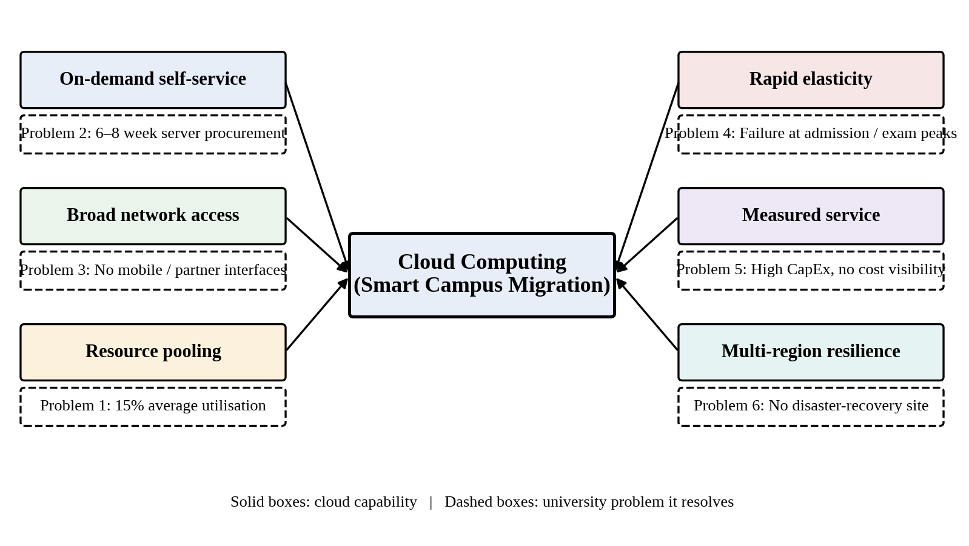
Figure 1: Mapping of the cloud characteristics to the university’s problems
Table 2: Core problems and the cloud characteristics that address them
Core problem | Evidence in the scenario | Characteristics | How the cloud addresses it
1. Rigid capacity | Average utilisation is about 15%, yet peaks exceed 95% and the applications fail during admissions, results and exams. | Resource pooling; rapid elasticity | Pooled capacity removes dedicated idle servers, and auto-scaling adds instances only for the peak weeks, so the university neither wastes capacity nor fails under load.
2. Slow, capital-heavy procurement | Each server takes 6–8 weeks to procure and requires high capital expenditure. | On-demand self-service; measured service | Resources are available in minutes, and spending moves from CapEx to pay-as-you-use OpEx with per-application cost visibility.
3. Single closed site | One data centre, no disaster-recovery site and no public interfaces for mobile apps or partner colleges. | Broad network access; resource pooling across regions | Services are exposed over standard network protocols, and a second cloud region provides disaster recovery without building a second data centre.

1.4 Deployment models and the model that suits the university
Table 3: Cloud deployment models compared for the university
Model | Description | Strengths and limitations for the university | Verdict
Public cloud | Infrastructure owned and operated by a provider and shared by many customers. | No CapEx, large elastic capacity, ready-made multi-region disaster recovery. Less direct control and data-residency questions must be managed. | Primary platform
Private cloud | Infrastructure dedicated to one organisation, on-premise or hosted. | Maximum control, but needs capital investment and cannot stretch for peak weeks, which repeats the present problem. | Not suitable as main model
Hybrid cloud | Two or more models joined by secure connectivity. | Allows phased migration, keeps legacy systems running during transition and permits bursting to the public cloud. | Suitable for the transition
Community cloud | Shared by organisations with common concerns, such as a consortium of colleges. | Shares cost and compliance effort, but needs governance and few providers exist. | Reconsider for the 40 affiliated colleges

Recommendation: a public-cloud-led hybrid model. All new workloads run in a public cloud region located in India, to meet data-residency expectations, while a secure VPN link keeps the remaining on-premise servers reachable during the migration. Once the migration is finished the on-premise estate is retired and the model converges on public cloud.

1.5 Benefits and limitations of cloud adoption

Benefits
- Cost: the university pays only for what it uses and avoids buying hardware sized for the three busiest weeks of the year.
- Scalability: auto-scaling absorbs admissions, result and exam peaks.
- Availability: multiple availability zones and a second region give the disaster recovery that does not exist today.
- Speed and manageability: capacity is ready in minutes and the provider patches and maintains the underlying hardware.
- Openness: web services and APIs make a mobile app and partner integration possible.

Limitations
- Vendor lock-in when proprietary services are used heavily.
- Internet dependence: all campuses need reliable connectivity.
- Data privacy and compliance: student records are personal data and fall under India’s Digital Personal Data Protection Act, 2023.
- Skills gap: the current staff are trained for physical servers rather than cloud operations.
- Cost surprises without budgets and monitoring, and the shared-responsibility model, under which the university remains responsible for identities, data and configuration.

TASK 2 – Trace the Evolution and Hardware Evolution (3 Marks)
Trace how computing infrastructure evolved to make cloud computing possible.

2.1 Timeline of computing infrastructure
Figure 2 places the seven stages on a timeline, with the hardware milestone that characterised each stage, and marks where the university stands today and where it is heading.
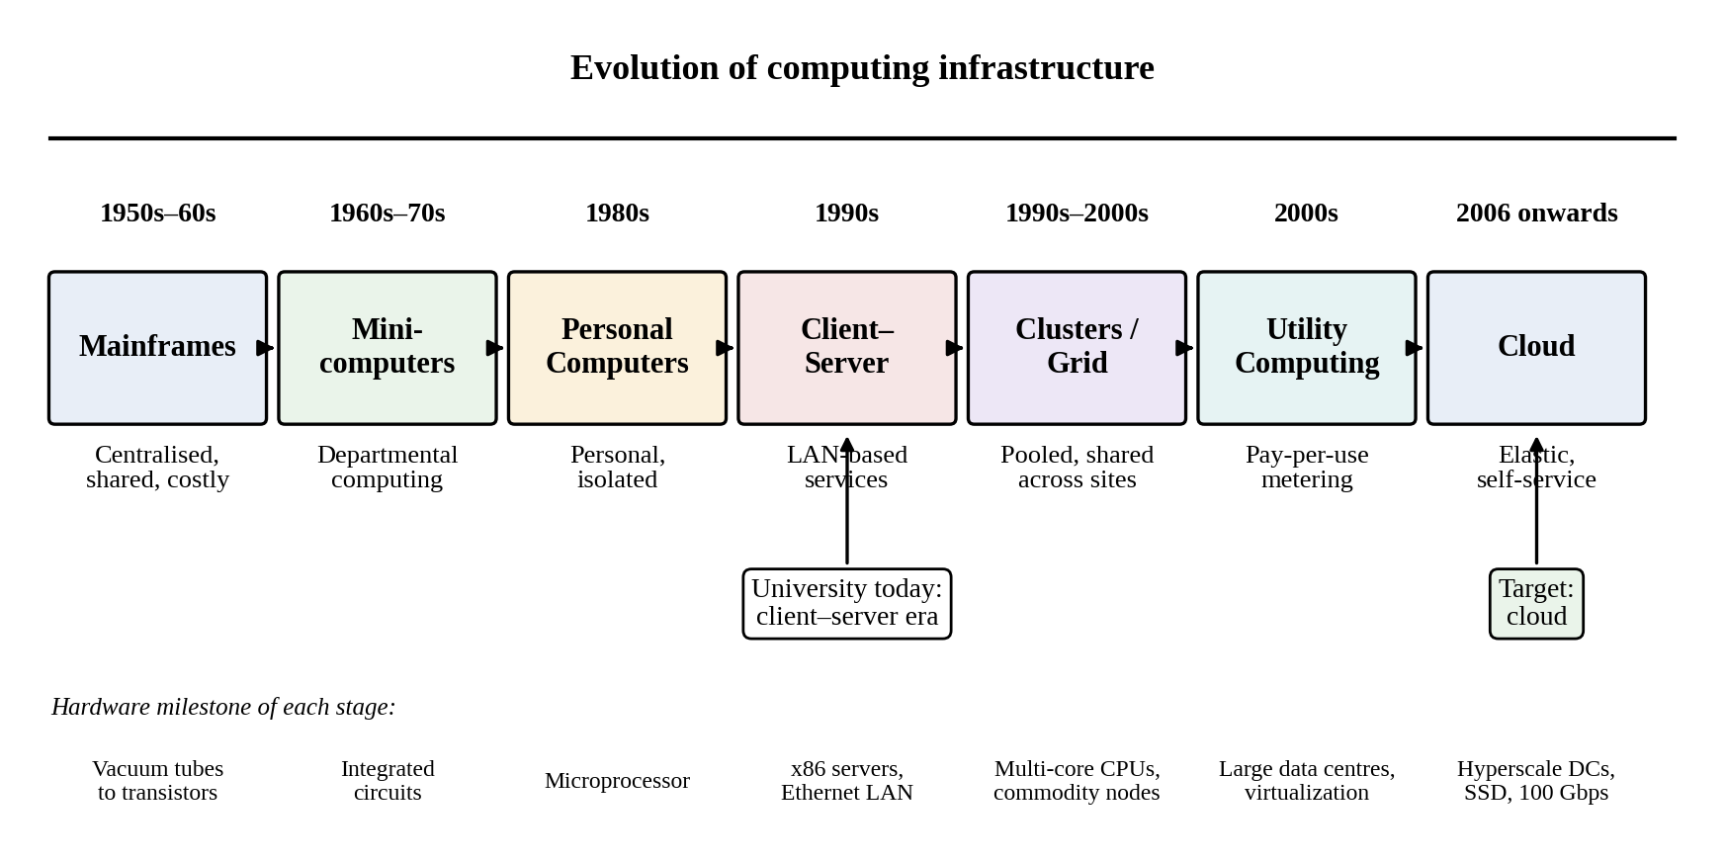
Figure 2: Timeline from mainframes to cloud computing, with hardware milestones

2.2 How each stage solved a limitation of the previous one
Table 4: Stages of evolution, the limitation each solved and the limitation that remained
Stage | Period | Key idea | Limitation solved | Remaining limitation
Mainframe | 1950s–60s | Centralised batch computing | Automated large calculations that were impossible by hand | Very expensive, single site, users queue for access
Minicomputer | 1960s–70s | Departmental machines with time-sharing | Lower cost and interactive use | Isolated islands of limited power
Personal computer | 1980s | Microprocessor-based machines for individuals | Personal ownership at low cost | Data silos and difficult management
Client–server | 1990s | Servers shared over a local network | Shared data and applications | One application per server, low utilisation, manual scaling
Cluster | 1990s | Many commodity machines acting as one | High performance and availability at modest cost | Fixed size, tied to one site, expert-driven
Grid | Late 1990s–2000s | Distributed resources pooled for large problems | Resource sharing across institutions | Complex to use, mainly scientific, no billing model
Utility computing | 2000s | Metered, pay-per-use computing | Introduced billing by consumption and flexible capacity | Lacked the virtualization and web APIs to deliver it at scale
Cloud | 2006 onwards | Virtualized, elastic, self-service resources through web APIs | Combined pooling, elasticity and metering | Provider dependence, security and lock-in concerns

2.3 Hardware evolution that enabled the cloud
Table 5: Hardware advances and their contribution to cloud computing
Advance | What changed | Contribution to the cloud
Multi-core processors | Performance gains came from adding cores rather than raising clock speed; CPUs gained virtualization extensions (Intel VT-x, AMD-V). | One host can run many virtual machines efficiently and in isolation.
Commodity servers | Standard x86 machines replaced proprietary mainframes. | Low-cost building blocks; reliability is provided by software and redundancy rather than expensive hardware.
High-capacity storage | Disks grew from megabytes to terabytes and were joined by SSD and NVMe, with distributed storage systems. | Cheap, durable object and block storage with snapshots and replication.
High-speed networking | Ethernet moved from 10 Mbps to 100 Gbps; broadband and mobile data spread. | Remote use of data-centre resources became practical for every user.
Data centres | Warehouse-scale facilities with automated power, cooling and orchestration. | Economies of scale and multiple regions and zones for resilience.

2.4 Stage of the university’s current system
The university’s current system corresponds to the client–server stage, in its dedicated-server form. The reasons are:
- Each application (SIS, LMS, Library, Exam Portal, Email) has its own dedicated server, so there is no resource pooling.
- Average utilisation of 15% shows that capacity is sized for a peak and sits idle for most of the year, which is the classic limitation of this stage.
- Capacity is fixed and growth requires 6–8 weeks of procurement, so there is no on-demand self-service or elasticity.
- The applications are monolithic programs with no public interfaces, and there is no metering by application.
- There is a single site without a disaster-recovery location, so even the redundancy of clustering is missing.
The migration therefore moves the university forward by several stages at once, from dedicated client–server machines to pooled, virtualized, metered and elastic cloud services, and each task that follows deals with one part of that step.

TASK 3 – Analyse Internet Software Evolution (3 Marks)
Explain how internet software evolved and why it supports cloud services.

3.1 Evolution from static pages to cloud-hosted applications
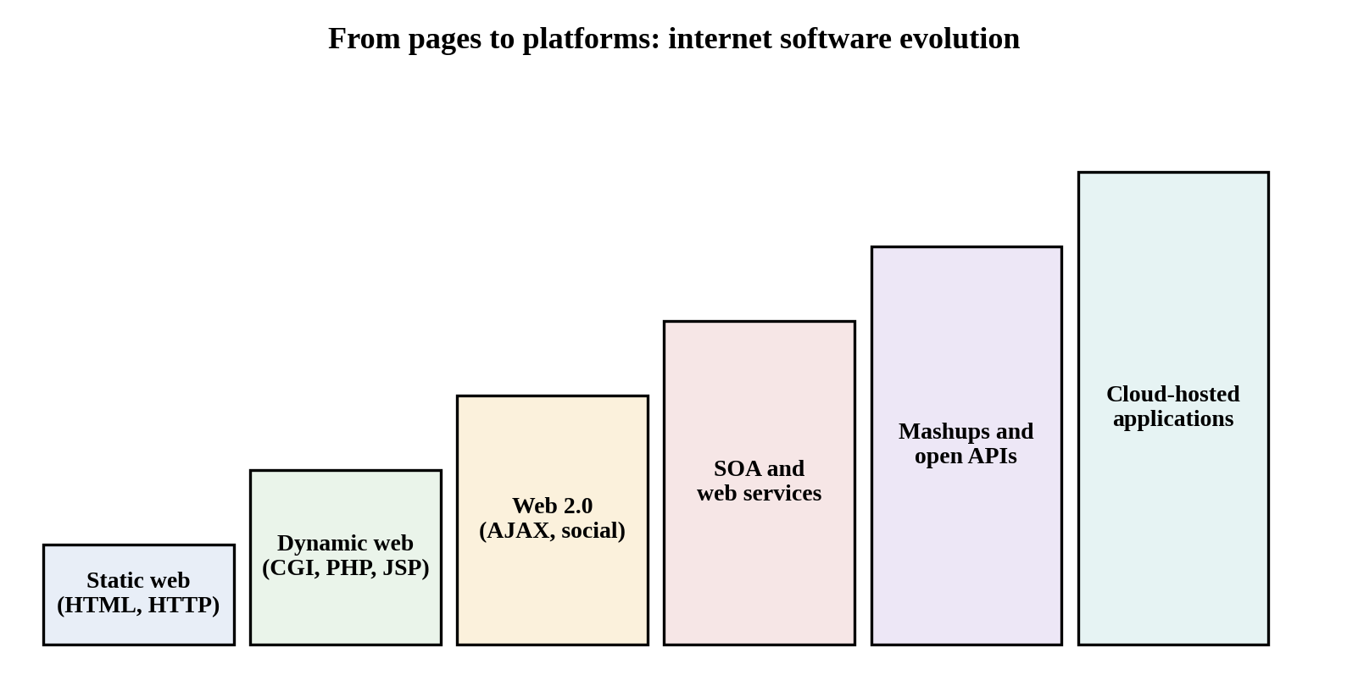
Figure 3: Stages of internet software evolution
- Static web (1990s): hand-written HTML pages served over HTTP; information only, no user-specific processing.
- Dynamic web: server-side technologies such as CGI, PHP and JSP generated pages from databases, which made online applications such as result look-up possible.
- Web 2.0: AJAX allowed pages to update without reloading, and users became contributors; the browser began to behave like an application.
- Service-oriented architecture (SOA): business functions were packaged as loosely coupled services with published interfaces that other systems can call.
- Mashups and open APIs: applications combine services from several providers through public APIs, for example a campus app combining timetable, fee and library data.
- Cloud-hosted applications: software runs on shared, elastic infrastructure and is delivered as a service through the browser or an app.

3.2 Role of browsers, HTTP, AJAX and APIs
Table 6: Technologies that deliver software over the internet
Technology | Role in delivering software over the internet
Browser | A universal client that renders the user interface, so nothing needs to be installed on the user’s device.
HTTP/HTTPS | The request–response protocol that carries pages and data; its methods (GET, POST, PUT, DELETE) and status codes are the basis of REST, and TLS protects the traffic.
AJAX | Asynchronous calls from the page to the server fetch small pieces of data, giving a responsive, application-like experience.
APIs | Published interfaces that let mobile apps, partner systems and other services use the university’s functions without access to its internal code.

3.3 Desktop, client–server and web-delivered software
Table 7: Comparison of software delivery models
Aspect | Desktop software | Client–server software | Web-delivered software
Installation | On every device | Client installed on each PC, server in the data centre | None; a browser or app is enough
Updates | Manual, device by device | Client and server must be updated together | Applied once on the server side
Scalability | Limited to the device | Limited by the fixed server | Scales out on elastic infrastructure
Platform dependence | High | Medium | Low
Access | Only on that device | Mostly on the campus network | Anywhere with internet access
Cost model | Licence per device | Servers plus client licences | Subscription or pay-per-use

3.4 Effect on the design of the university’s applications
The current applications are large monolithic programs closer to the client–server stage. The software evolution described above implies the following design changes:
- Split the monolith into services with clear boundaries (results, fees, library, exams), so that busy functions can scale independently of quiet ones.
- Adopt an API-first approach so the web front end, the mobile app and the partner colleges all use the same interfaces.
- Make the application tier stateless, keeping session data in a cache or database so any instance can serve any request and auto-scaling works.
- Use thin, browser-based clients and responsive pages instead of software installed on lab computers.
- Secure and monitor at the API layer with authentication, rate limits and logging, because the services are now reachable from outside the campus.

TASK 4 – Apply Server Virtualization (5 Marks)
Apply server virtualization to consolidate the university’s 12 physical servers.

4.1 How a hypervisor works; Type-1 and Type-2 hypervisors
A hypervisor (virtual machine monitor) is a thin software layer that abstracts the physical CPU, memory, storage and network and divides them among several isolated virtual machines (VMs). Each VM has its own guest operating system and believes it owns a complete computer. The hypervisor schedules virtual CPUs on physical cores, maps virtual memory to physical memory, and mediates all access to devices, so that one VM cannot read or disturb another.
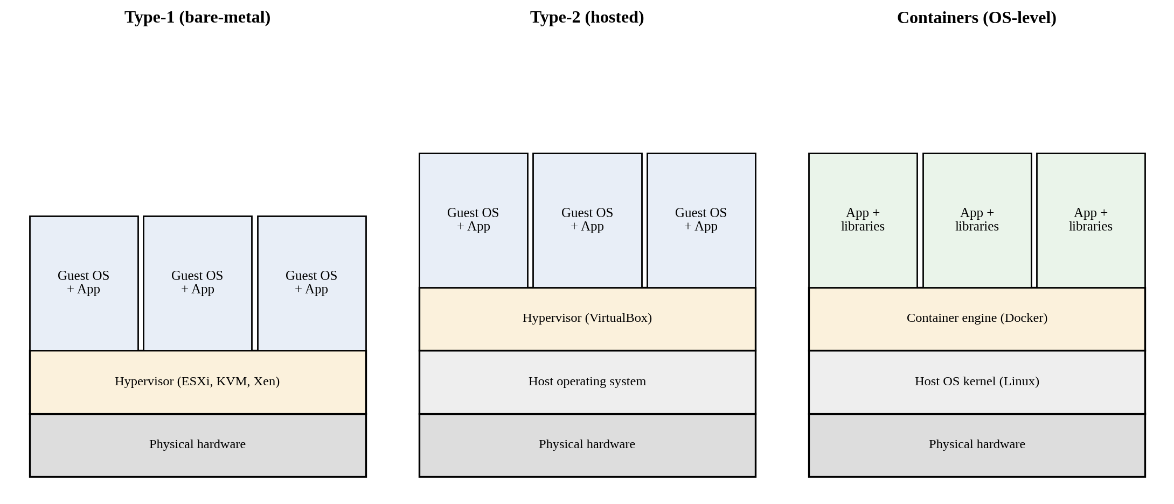
Figure 4: Type-1 hypervisor, Type-2 hypervisor and container architectures
Table 8: Type-1 and Type-2 hypervisors
Feature | Type-1 (bare-metal) | Type-2 (hosted)
Runs on | Directly on the physical hardware | On top of a host operating system
Performance | High, with little overhead | Lower, because the host OS sits in the path
Typical use | Production data centres and cloud platforms | Developer desktops, labs and testing
Examples | VMware ESXi, Microsoft Hyper-V, KVM, Xen | Oracle VirtualBox, VMware Workstation
Suitability here | Used for the consolidated university hosts | Used only by staff for the proof-of-concept in Task 9

4.2 Virtualization techniques compared
Table 9: Full, para-, OS-level and hardware-assisted virtualization
Technique | How it works | Guest changes | Performance and isolation | Example
Full virtualization | Emulates complete hardware; privileged instructions are trapped or translated by the hypervisor. | None; unmodified guest OS | Strong isolation; some overhead without hardware support | VMware ESXi, KVM
Para-virtualization | The guest kernel is modified to call the hypervisor (hypercalls) instead of using privileged instructions. | Guest kernel must be modified | Better than software-only full virtualization; less portable | Xen PV drivers
OS-level virtualization (containers) | Containers share the host kernel while each has its own isolated processes, file system and network. | None, but guest must use the host kernel type | Near-native speed, starts in seconds; weaker isolation than VMs | Docker, LXC
Hardware-assisted virtualization | CPU extensions (Intel VT-x, AMD-V, nested page tables) let the hardware run guest code safely. | None | Removes most overhead of full virtualization; the basis of modern hypervisors | KVM, Hyper-V

4.3 Applications as virtual machines or containers
During the consolidation of the on-premise estate, the placement in Table 10 is proposed. VMs are used where strong isolation, a full operating system or stateful software is needed, and containers are used for lightweight, stateless services that must start quickly and scale.
Table 10: Proposed placement of the university applications
Application | Runs as | Reason
Student Information System (SIS) | VM (first), containers later | Legacy monolith with a database and strict data protection needs; a VM preserves the existing environment and gives strong isolation. It is decomposed into containers in a later phase.
Learning Management System (LMS) | Containers | Web application whose load rises sharply in term time; stateless web tier scales by adding containers.
Library system | Container | Small, low-load web application; one container uses a fraction of a host.
Exam Portal | Containers | Highest and most sudden peaks; containers start in seconds and can be scaled out quickly during exams.
Email | VM | Mail servers are stateful, long-running and sensitive to disk and network behaviour; a VM is the safer unit until the service moves to SaaS.
Databases | Dedicated VMs | Need predictable I/O, strong isolation and snapshot-based backup.

4.4 Consolidation calculation

Assumptions
- All 12 existing servers have the same capacity, and each new virtualization host has the capacity of one existing server. This is a conservative assumption, because modern hosts usually have more cores.
- Average CPU utilisation is 15% per server, and the target utilisation of a host is 70%. The remaining 30% covers hypervisor overhead and short bursts.
- The 12 servers are assigned as SIS 3, LMS 3, Library 1, Exam Portal 3 and Email 2. This split is assumed because the scenario does not state it.
- Applications peak at 95% on their own servers only during their own peak weeks: SIS in admissions, and Exam Portal and LMS in exam and result weeks.
- The calculation uses CPU only. Memory, storage I/O and network must be validated by measurement before purchase.

Working for the average day
Total useful load = 12 servers × 15% = 1.8 server-equivalents.
Hosts required = total load ÷ target utilisation = 1.8 ÷ 0.70 = 2.57, which rounds up to 3 hosts.
One additional host is added so that a host can fail or be drained for maintenance while the others carry the load (N+1), giving 4 physical hosts. The estate shrinks from 12 servers to 4 hosts, a reduction of 67%, and utilisation rises from 15% to about 45% (1.8 ÷ 4) on a normal day.

Working for the peak weeks
Table 11: Consolidation requirement under average and peak load
Scenario | Load calculation (server-equivalents) | Total | Hosts at 70%
Average day | 12 × 0.15 | 1.80 | 1.80 ÷ 0.70 = 2.6, so 3 (4 with N+1)
Admissions peak | SIS 3 × 0.95 = 2.85; LMS 0.45; Library 0.15; Exam 0.45; Email 0.30 | 4.20 | 4.20 ÷ 0.70 = 6.0, so 6
Exam and result peak | Exam 3 × 0.95 = 2.85; LMS 3 × 0.95 = 2.85; SIS 0.45; Library 0.15; Email 0.30 | 6.60 | 6.60 ÷ 0.70 = 9.4, so 10

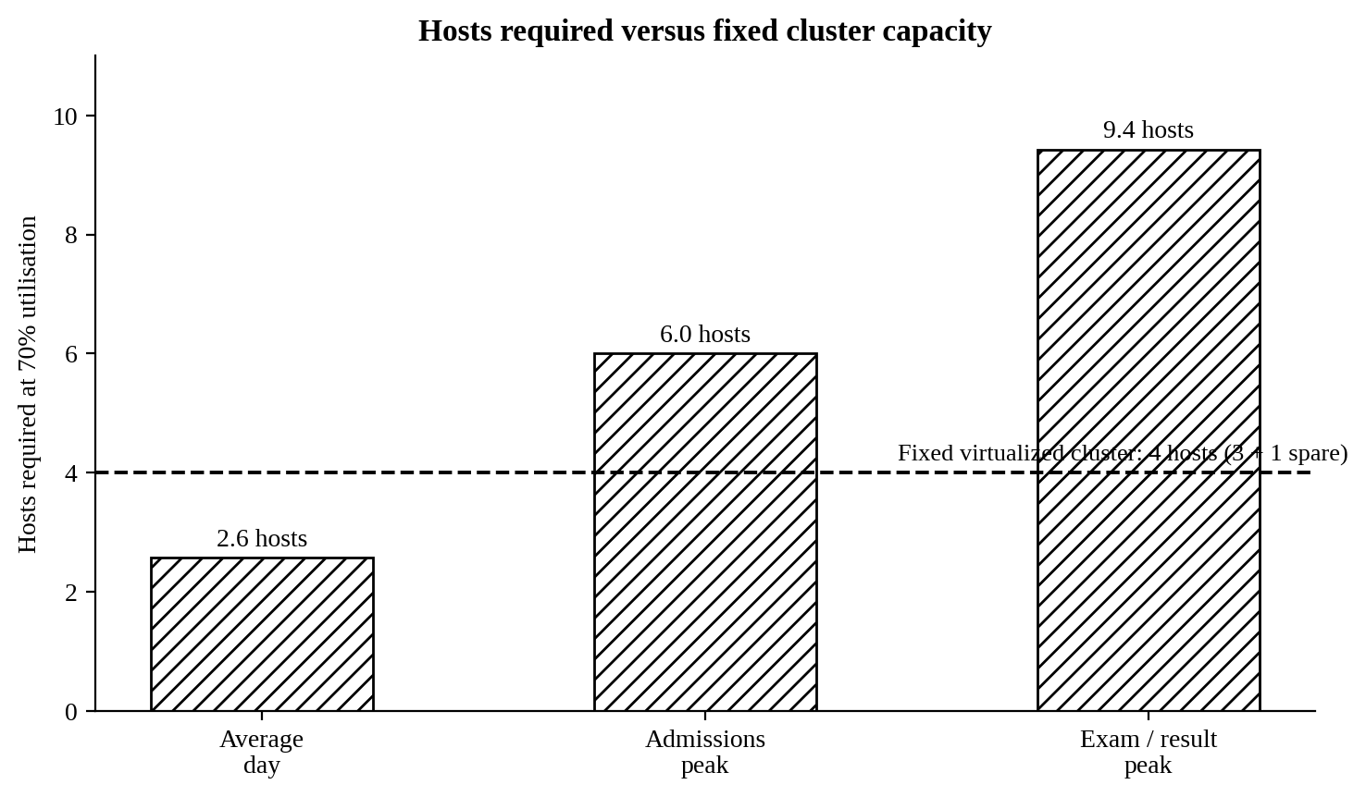
Figure 5: Hosts required in each scenario compared with a fixed four-host cluster
Interpretation and peak-load caution. A four-host cluster is enough for the average day but is 1.5 to 2.5 times too small for the peak weeks. Buying ten hosts to cover three or four busy weeks would again leave most of them idle. Consolidation therefore solves the waste, but not the peak, and this is the reason the design in Task 8 relies on elastic cloud capacity rather than a fixed virtualized cluster. The figures are estimates and must be confirmed by load testing.

4.5 Benefits and risks of virtualization
Table 12: Benefits and risks of virtualization with mitigations
Topic | Benefit or risk | Mitigation or use
Live migration | Benefit: a running VM moves to another host without downtime. | Used for hardware maintenance and for balancing load across hosts.
Snapshots | Benefit: the state of a VM can be captured and restored quickly. | Taken before upgrades for fast rollback, but not treated as a substitute for backups.
Resource over-commitment | Benefit: more virtual CPUs and memory are promised than exist physically because VMs seldom peak together. | Over-commit CPU moderately; avoid over-committing memory for databases; monitor usage.
Noisy neighbour | Risk: a busy VM takes CPU, disk or network capacity from others. | Resource limits and reservations; place the Exam Portal and LMS on separate hosts.
Hypervisor or host failure | Risk: a single host failure takes down every VM on it. | N+1 spare capacity, high-availability restart on another host, spreading VMs across hosts.
Security isolation | Risk: a flaw could let one VM reach another or the hypervisor. | Patch the hypervisor promptly, separate networks per tier, minimise the management network exposure.

TASK 5 – Apply Web Services (4 Marks)
Analyse web services to expose the university’s functions to other systems.

5.1 Web services and their role in cloud and SOA
A web service is a software function made available over a network through standard protocols so that other programs can call it, regardless of the language or platform in which either side is written. In a service-oriented architecture (SOA), business capabilities such as “look up a result” become independent services with published contracts. In the cloud, web services are the way every other component is controlled and consumed: virtual machines are created through APIs, SaaS products are integrated through APIs, and the mobile app and the 40 colleges will use the university’s services in exactly the same way. Figure 6 shows the path of a typical call.
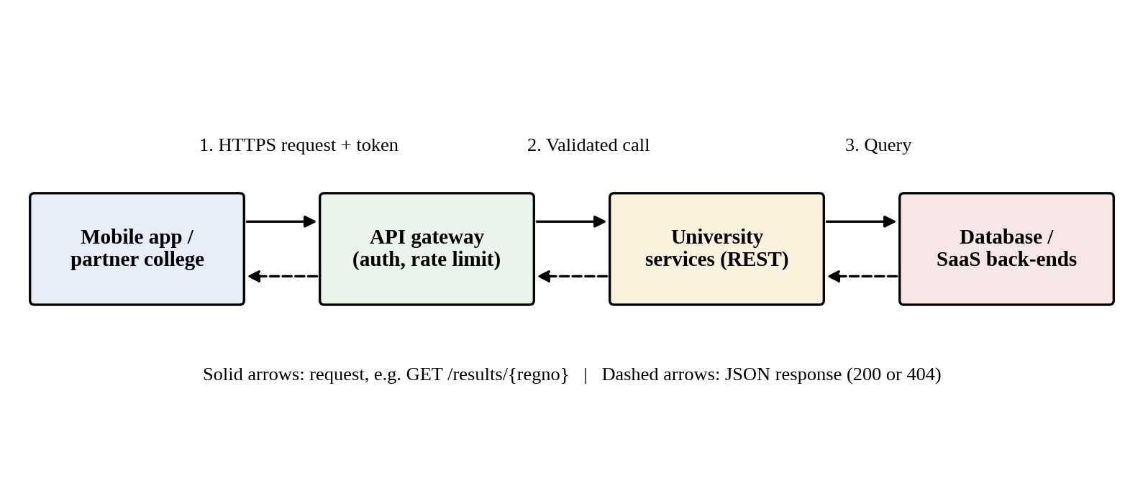
Figure 6: Request and response path of a university web service call

5.2 SOAP, WSDL, UDDI and REST compared
Table 13: Comparison of SOAP, WSDL, UDDI and RESTful services
Aspect | SOAP | WSDL | UDDI | REST
Nature | Protocol with a strict XML message envelope | XML language that describes a service’s operations and messages | Directory in which services are published and discovered | Architectural style that uses ordinary HTTP
Format | XML only | XML | XML registry entries | JSON (usual), XML or others
Methods | Operations defined in the contract, usually over HTTP POST | Defines operations and bindings | Lookup of service descriptions | HTTP verbs: GET, POST, PUT, DELETE on resources
Contract | Formal, described by WSDL | The contract itself | Not applicable | Informal; documented with OpenAPI
Weight | Heavy; more bandwidth and parsing | Verbose | Largely obsolete in practice | Light, easy to cache, easy for mobile apps
Security and transactions | WS-Security, WS-AtomicTransaction built in | Not applicable | Not applicable | HTTPS, OAuth 2.0, tokens; transactions handled by design

5.3 University functions exposed as web services
Three functions are exposed: result look-up, fee payment and library search. Table 14 defines each endpoint, and the sample messages that follow were produced by the working prototype built in Task 9.
Table 14: Web service definitions
Function | Endpoint | Method | Success and failure responses
Result look-up | /api/v1/results/{regno} | GET | 200 OK with the result; 404 Not Found if the register number does not exist
Fee payment | /api/v1/fees/payments | POST | 201 Created with a receipt; 400 Bad Request if data are missing
Library search | /api/v1/library/books?title={text} | GET | 200 OK with a (possibly empty) list of books

Result look-up
Request: GET /api/v1/results/UNI2026001
Response: 200 OK Content-Type: application/json
{"gpa":8.4,"name":"Student A","regno":"UNI2026001","semester":5,"status":"PASS"}

Failure: GET /api/v1/results/UNI9999999
Response: 404 NOT FOUND
{"error":"Result not found","regno":"UNI9999999"}

Fee payment
Request: POST /api/v1/fees/payments Content-Type: application/json
{"regno":"UNI2026001","amount":42500}
Response: 201 CREATED
{"amount":42500,"receiptId":"RCPT-00001","status":"SUCCESS"}

Library search
Request: GET /api/v1/library/books?title=cloud
Response: 200 OK
{"count":1,"items":[{"available":2,"isbn":"978-0321125217",
"title":"Cloud Computing: Concepts and Design"}]}

5.4 SOAP or REST for each function
Table 15: Choice of SOAP or REST for each function
Function | Choice | Justification
Result look-up | REST | Read-only, cacheable lookup used heavily by mobile phones during result week. JSON keeps payloads small, and GET responses can be cached by a CDN or gateway to absorb the peak.
Fee payment | REST over HTTPS with OAuth 2.0 | The mobile app and colleges need a lightweight interface. Safety comes from TLS, tokens and an idempotency key that prevents double charging. SOAP with WS-Security would be considered only if a partner bank mandates it, and it would then be hidden behind an adapter service.
Library search | REST | Public, read-only, simple query parameters, no need for formal contracts or transactions.

In summary, REST suits all three functions because the dominant consumers are mobile and browser clients and the operations are simple and stateless. SOAP and WSDL remain relevant only for integrating with older partner or banking systems that already depend on them.

TASK 6 – Analyse the Service Models: IaaS, PaaS and SaaS (5 Marks)
Analyse which service model fits each university application.

6.1 Definitions and responsibility layers
- Infrastructure as a Service (IaaS) provides virtualized servers, storage and networks. The customer installs and manages the operating system, runtime and applications.
- Platform as a Service (PaaS) provides a managed runtime and middleware for deploying applications. The customer manages only the application and its data.
- Software as a Service (SaaS) provides a complete application used through a browser or app. The customer manages only configuration, users and content.
Table 16: Who manages each layer in each model (C = customer, P = provider)
Layer | On-premise | IaaS | PaaS | SaaS
Application | C | C | C | P
Data | C | C | C | P (customer owns the content)
Runtime | C | C | P | P
Middleware | C | C | P | P
Operating system | C | C | P | P
Virtualization | C | P | P | P
Servers | C | P | P | P
Storage | C | P | P | P
Networking | C | P | P | P

6.2 Categorisation of the five applications
Table 17: Service model chosen for each university application
Application | Service model | Example product type
Student Information System (SIS) | IaaS now; PaaS later | Virtual machines with a managed database, then a managed application platform
Learning Management System (LMS) | SaaS | Hosted learning platform such as Moodle hosting, Canvas or Google Classroom
Library system | SaaS | Hosted library management service
Exam Portal | PaaS | Auto-scaling managed application platform
Email | SaaS | Microsoft 365 or Google Workspace for Education

A table alone does not justify a decision, so the reasoning for each application follows.
SIS – IaaS first, then PaaS. The SIS is a legacy monolith holding the most sensitive data. Moving it unchanged onto VMs (rehosting) is the fastest and lowest-risk first step because it needs no code change and still removes the physical servers. It needs full control of the operating system and database configuration during that phase. Once the database is moved to a managed service and the code is containerised, the SIS can move to PaaS to reduce maintenance.
LMS – SaaS. Learning management is a commodity function. Mature products exist, and the university gains little by running its own servers. SaaS removes patching and gives elasticity during term time. The limitation is lower customisation and some lock-in, which is acceptable for a standard teaching function.
Library – SaaS. The library system is small, low-risk and standardised around cataloguing and circulation. Operating servers for it would cost more in effort than the service is worth, so a hosted service is the most economical choice.
Exam Portal – PaaS. This is custom, business-critical software with the sharpest and shortest peaks, which makes elasticity the main requirement. PaaS auto-scales the runtime without the staff managing servers, and the university retains control of the code and its exam rules, which SaaS would not allow.
Email – SaaS. Email is the clearest SaaS candidate: it is standard, needed around the clock, expensive to run securely (spam filtering, security patches, storage) and offered to educational institutions at low or no licence cost by large providers.

6.3 Comparison of the three models
Table 18: IaaS, PaaS and SaaS compared
Criterion | IaaS | PaaS | SaaS
Control | Highest: OS, runtime and software | Medium: application and data | Lowest: configuration only
Cost | Pay for allocated VMs; staff time for management is extra | Moderate; pay for runtime and scaling, less staff time | Per-user subscription; predictable and often lowest total cost for standard needs
Scalability | Possible, but the customer builds auto-scaling | Built-in auto-scaling | Handled by the provider
Maintenance effort | High: patching, security, backups | Low to medium: application only | Very low
Vendor lock-in | Low to medium; VMs are portable | Medium to high; platform-specific services | High; data export may be difficult
Typical provider | Amazon EC2 | Azure App Service, Google App Engine | Microsoft 365, Google Workspace

The providers named above are given as one real example for each model: Amazon Web Services EC2 for IaaS, Google App Engine for PaaS, and Microsoft 365 for SaaS.

TASK 7 – Examine XaaS (3 Marks)
Examine the broader XaaS (Anything-as-a-Service) concept for the university.

7.1 XaaS and its variants
XaaS, or Anything-as-a-Service, extends the IaaS, PaaS and SaaS idea to any capability that can be delivered over the network on a subscription or pay-per-use basis. Table 19 describes six variants and their relevance to the university.
Table 19: Six XaaS variants and their relevance
Variant | What is delivered | Relevance to the university
Desktop as a Service (DaaS) | Virtual desktops streamed to any device | Lets computer labs and staff use full desktops from low-cost devices.
Backend / Mobile Backend as a Service (BaaS/MBaaS) | Ready-made authentication, push notifications and data storage for apps | Speeds up the mobile app, particularly push notifications.
Function as a Service (FaaS) | Event-driven code run per execution without servers | Suits short tasks such as generating fee receipts or sending results alerts.
Database as a Service (DBaaS) | A managed database with backup, patching and replication | Moves the most critical component off staff-managed servers.
Security as a Service (SECaaS) | Managed web firewall, identity, malware and threat detection | Protects public-facing services without a large in-house security team.
Disaster Recovery as a Service (DRaaS) | Replication of workloads to a recovery site with orchestrated failover | Provides the disaster recovery site the university does not have.

7.2 Two XaaS offerings selected
Database as a Service (DBaaS). The SIS database is the university’s most valuable asset and the component most likely to be a bottleneck. DBaaS supplies automated backups, point-in-time recovery, patching, multi-zone failover and read replicas, tasks the current team would otherwise perform manually. It reduces the skills gap identified in Task 1 and raises availability. Its cost is higher than a self-managed database on a VM, but the saving in staff effort and the lower risk of data loss outweigh it.
Disaster Recovery as a Service (DRaaS). The university has no recovery site at all, and building a second data centre would cost more than the entire annual cloud bill. DRaaS replicates the application and data to a second region and pays for the full environment only during a failover or test. It offers a defined recovery time and recovery point at a small fraction of the cost of an owned site.
FaaS and SECaaS were considered as well. They are valuable and are adopted in the revised design in Task 11, but DBaaS and DRaaS deal with the two most serious gaps in the present system, which are data protection and resilience.

7.3 Risks of over-reliance on many “as-a-Service” providers
- Vendor lock-in: each proprietary service adds to the effort needed to leave a provider.
- Cascading dependency and outages: the failure of a single provider (for example an identity service) can stop several applications at once.
- Integration complexity: many providers mean many contracts, interfaces, support desks and security reviews.
- Data governance: student data spread over several providers makes compliance and breach response harder.
- Cost sprawl: many small subscriptions can quietly add up to more than the single platform they replaced.
- Mitigations: keep an inventory of services, choose open standards and exportable data formats, place critical services behind an abstraction layer, test exit and restore procedures, and review contracts and SLAs annually.

TASK 8 – Design the Cloud Solution Architecture (5 Marks)
Create a complete cloud architecture for the university by combining virtualization, web services and service models.

8.1 Architecture diagram
Figure 7 shows the proposed architecture. Users reach the platform through DNS, a content delivery network and a web application firewall. A multi-zone load balancer distributes traffic to the PaaS application tier, which exposes the REST API layer and keeps its data in a managed multi-zone database and encrypted object storage. Email, the LMS and the library run as SaaS outside the application tier. A second region holds the disaster-recovery copy.
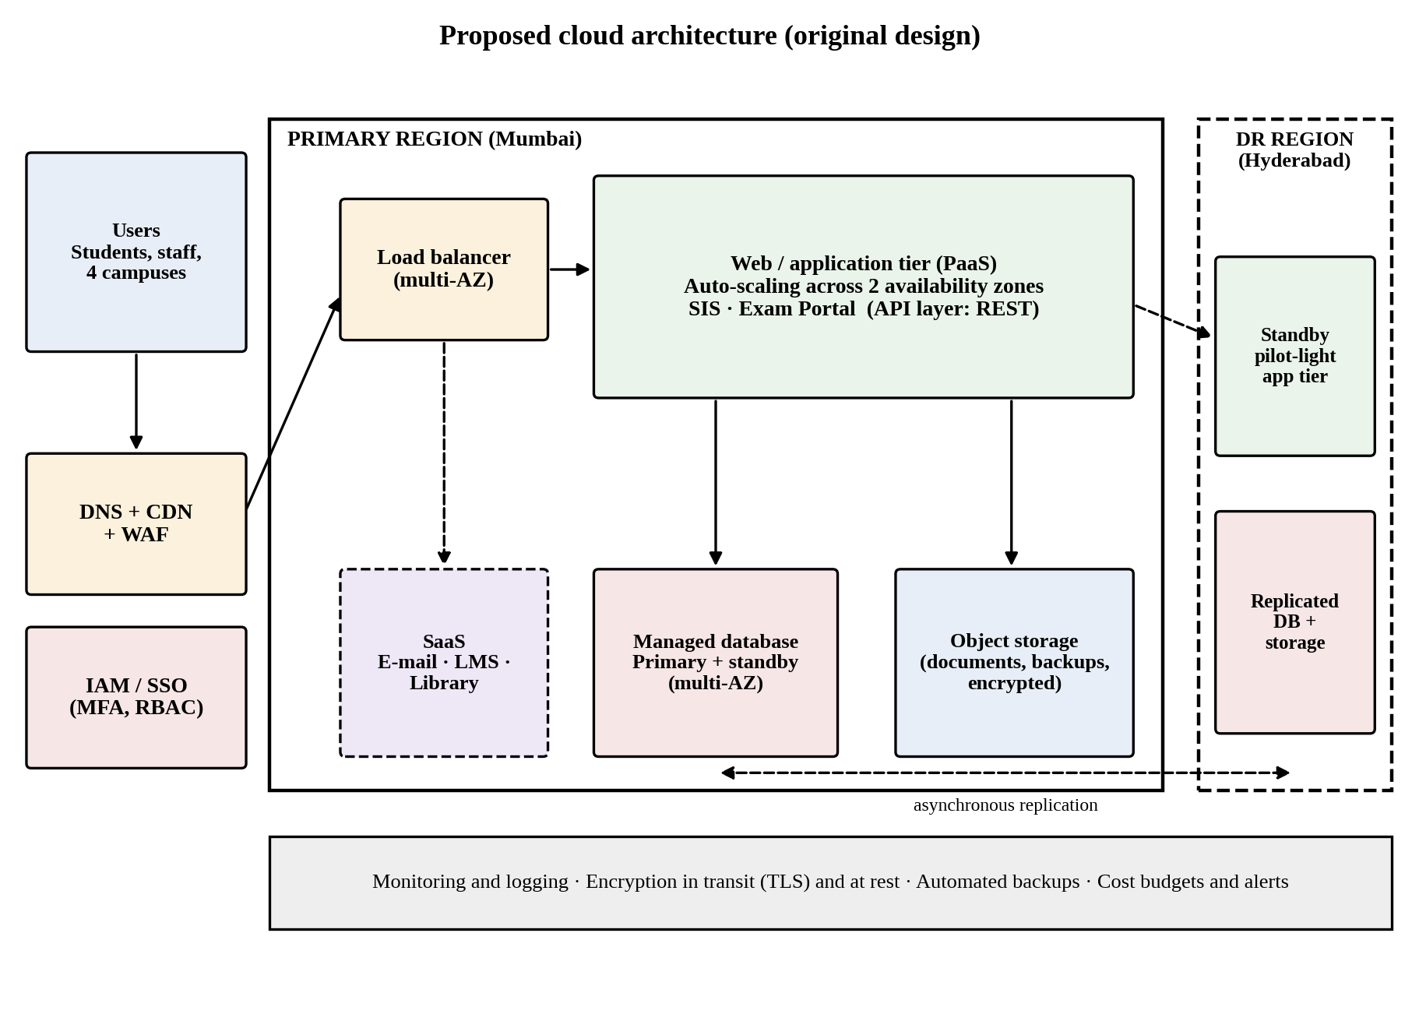
Figure 7: Proposed cloud architecture for the university (original design)

8.2 Deployment and service model for each component
Table 20: Components, models and justification
Component | Deployment model | Service model | Justification
DNS, CDN and web application firewall | Public | XaaS (SECaaS) | Absorbs traffic, caches static content and filters attacks before they reach the application.
Load balancer | Public, multi-zone | IaaS service | Distributes traffic across zones and removes unhealthy instances.
Web and application tier (SIS front end, Exam Portal) | Public | PaaS | Auto-scaling runtime with no server management; code remains under university control.
API layer | Public | PaaS (REST) | Single, versioned set of interfaces for web, mobile and partners.
Database tier | Public, multi-zone | DBaaS | Managed backups, failover and patching for the SIS data.
Object storage | Public | IaaS storage | Durable, cheap storage for documents, exam material and backups, encrypted at rest.
Email, LMS, Library | Public | SaaS | Standard functions better bought than built.
DR region | Public, second region | DRaaS | Replicated data and a pilot-light application tier for recovery.
Connectivity to legacy servers | Hybrid | IaaS networking | VPN link used only during the migration.
Identity and access | Public | SaaS / SECaaS | Single sign-on with multi-factor authentication for staff and students.

8.3 Elasticity and auto-scaling for admissions and exam peaks
The current peak is assumed to be 5,000 concurrent users, each generating about 10 requests per minute, which is about 830 requests per second. If one application instance with 2 vCPU can serve about 100 requests per second (to be confirmed by a load test), the peak needs 9 instances; adding 30% headroom gives 12, and one spare instance in each of the two availability zones gives 14. The auto-scaling group is therefore configured as follows:
- Minimum 4 instances (two per zone) for the quiet periods, and maximum 20 instances as a cost ceiling.
- Target-tracking policy: add instances when average CPU exceeds 60% and remove them when it falls below 30%.
- Scheduled scaling: raise the minimum to 12 a day before admissions, result publication and each exam week, because reactive scaling needs a few minutes to start instances.
- Queue-based buffering for non-urgent work such as generating PDFs, so that these tasks do not compete with student requests.
- Cache and CDN for read-heavy pages such as result lookups, which reduces load on the database.

8.4 Security and availability measures
Table 21: Security and availability controls
Area | Measure | Purpose
Access control | Single sign-on, multi-factor authentication, role-based access, least privilege, separate admin accounts | Limits who can reach and change student data.
Encryption | TLS 1.2 or higher in transit; AES-256 at rest with managed keys | Protects data on the network and on disk.
Network security | Private subnets for application and database tiers, security groups, web application firewall | Only the load balancer is reachable from the internet.
Backup | Automated daily backups with point-in-time recovery, copied to the DR region | Recovery from deletion, corruption or ransomware.
Multi-zone deployment | Application and database spread across two availability zones | Survives the loss of one data centre.
Disaster recovery | Replication to a second region with a pilot-light environment; targets of recovery point 15 minutes and recovery time 4 hours | Survives the loss of a whole region.
Monitoring | Central logs, alarms on CPU, errors and latency, budget alerts | Early warning of failures, attacks and cost overruns.

Design limits. The instance counts, the 100 requests-per-second capacity and the recovery targets are sizing assumptions. They are validated by the load test and the failover drill included in the roadmap in Task 10.

TASK 9 – Hands-on Implementation and Documentation (4 Marks)
Implement a small proof-of-concept of your design using a free-tier cloud account or a local virtualization tool.

9.1 Objective and environment
The proof-of-concept implements the three university web services of Task 5 as a small REST API, packaged so that it can run in a container and be deployed to a managed PaaS. It proves the application tier of the design in Figure 7: a stateless service reached over HTTP that can be started in several copies behind a load balancer.
Table 22: Environment used
Item | Detail
Operating system | Ubuntu 24 (Linux), 64-bit
Language and framework | Python 3.12 with Flask 3.1
Production server | Gunicorn, used inside the container
Container tool | Docker (Dockerfile provided below)
Test client | curl 8.x from the command line (Postman or a browser can be used equally)
Data | Small in-memory sample data set standing in for the managed database

9.2 Source code
The complete application (app.py) is listed below. It defines a health check and the three services of Task 5.
from flask import Flask, jsonify, request
app = Flask(__name__)

RESULTS = {
"UNI2026001": {"name": "Student A", "semester": 5, "gpa": 8.4, "status": "PASS"},
"UNI2026002": {"name": "Student B", "semester": 5, "gpa": 7.1, "status": "PASS"},
}
BOOKS = [
{"isbn": "978-0131103627", "title": "The C Programming Language", "available": 3},
{"isbn": "978-0134093413", "title": "Computer Networks", "available": 0},
{"isbn": "978-0321125217", "title": "Cloud Computing: Concepts and Design", "available": 2},
]
PAYMENTS = []

@app.get("/health")
def health():
return jsonify(status="UP"), 200

@app.get("/api/v1/results/<regno>")
def get_result(regno):
rec = RESULTS.get(regno)
if rec is None:
return jsonify(error="Result not found", regno=regno), 404
return jsonify(regno=regno, **rec), 200

@app.get("/api/v1/library/books")
def search_books():
q = request.args.get("title", "").lower()
hits = [b for b in BOOKS if q in b["title"].lower()]
return jsonify(count=len(hits), items=hits), 200

@app.post("/api/v1/fees/payments")
def pay_fee():
body = request.get_json(silent=True) or {}
if not body.get("regno") or not body.get("amount"):
return jsonify(error="regno and amount are required"), 400
PAYMENTS.append(body)
return jsonify(receiptId=f"RCPT-{len(PAYMENTS):05d}", status="SUCCESS", amount=body["amount"]), 201

if __name__ == "__main__":
app.run(host="0.0.0.0", port=5000)

The container definition (Dockerfile) and dependency list (requirements.txt) are:
# Dockerfile
FROM python:3.12-slim
WORKDIR /app
COPY requirements.txt .
RUN pip install --no-cache-dir -r requirements.txt
COPY app.py .
EXPOSE 5000
CMD ["gunicorn", "-b", "0.0.0.0:5000", "-w", "2", "app:app"]

# requirements.txt
flask==3.1.0
gunicorn==23.0.0

9.3 Configuration and execution steps
Step 1 Create a folder and save app.py, requirements.txt and Dockerfile in it.
Step 2 pip install flask (local test only)
Step 3 python3 app.py (starts the service on port 5000)
Step 4 Open a second terminal and run the curl tests in section 9.4.

Figure 8 shows the service starting and logging each request it receives while the tests were run.
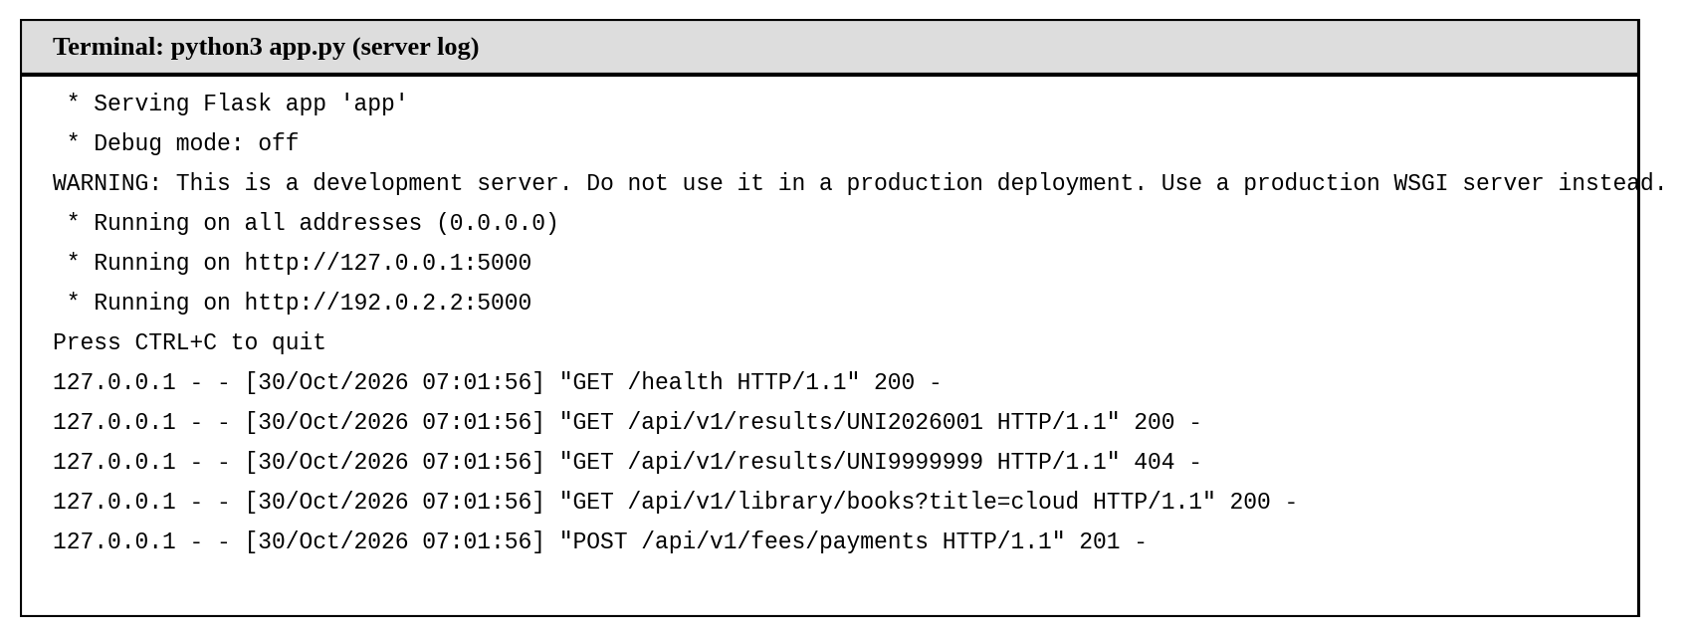
Figure 8: Terminal capture of the service running and logging requests

9.4 Testing the web service and recorded output
Each test below was executed against the running service, and the outputs in Figures 9 to 11 are the actual responses recorded.
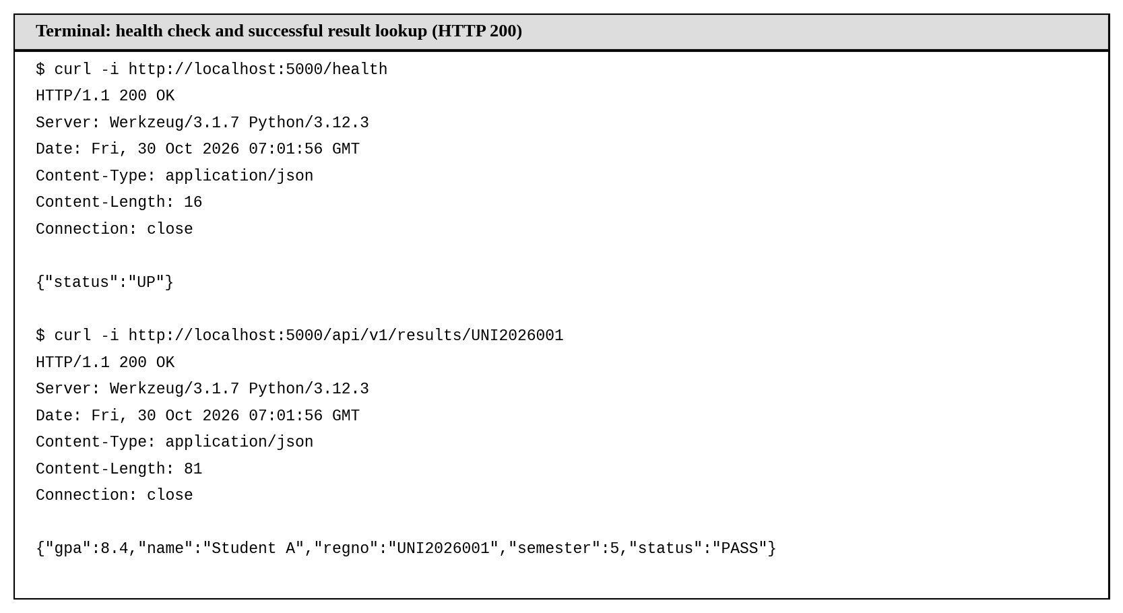
Figure 9: Health check and successful result look-up returning HTTP 200
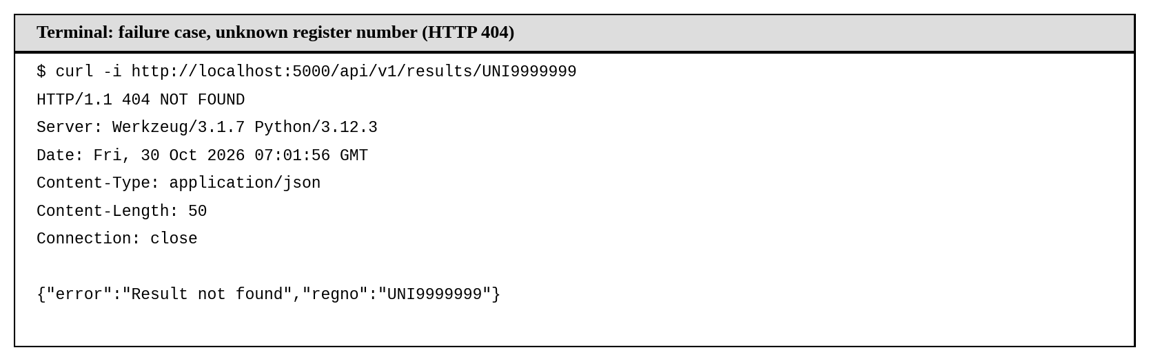
Figure 10: Failure case: unknown register number returning HTTP 404
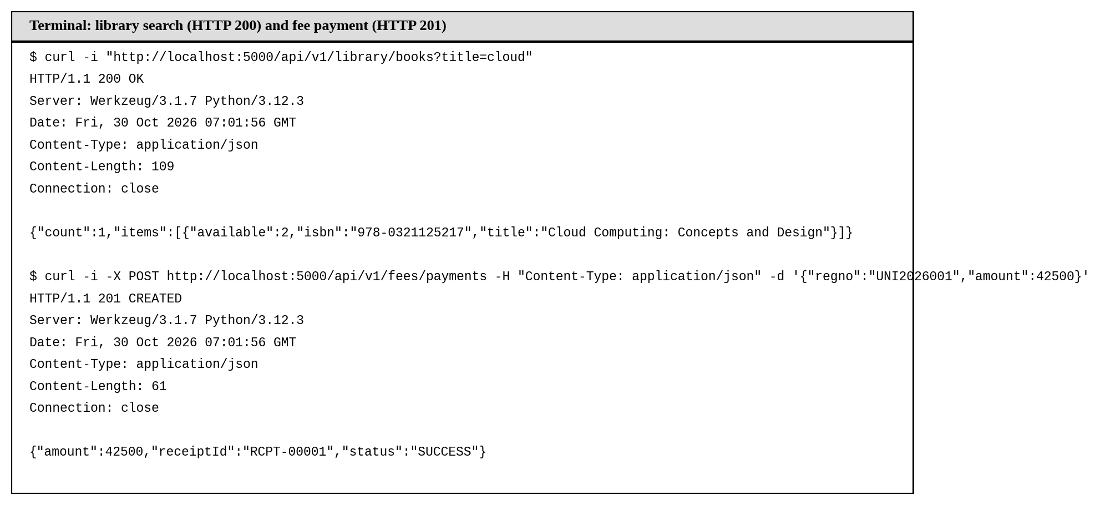
Figure 11: Library search (HTTP 200) and fee payment (HTTP 201)
Table 23: Test results
No. | Test | Expected | Actual | Result
1 | GET /health | 200, status UP | 200, {"status":"UP"} | Pass
2 | GET /api/v1/results/UNI2026001 | 200 with result JSON | 200, GPA 8.4, status PASS | Pass
3 | GET /api/v1/results/UNI9999999 | 404 with error JSON | 404, {"error":"Result not found"} | Pass
4 | GET /api/v1/library/books?title=cloud | 200 with one book | 200, count 1 | Pass
5 | POST /api/v1/fees/payments (valid body) | 201 with receipt | 201, receiptId RCPT-00001 | Pass

9.5 Container and PaaS deployment procedure
The service is containerised and then deployed to a managed platform. A serverless container service such as Google Cloud Run, Azure Container Apps or AWS App Runner on a free tier is used, because it is PaaS: the provider manages servers, operating system and scaling.
# A. Build and run the container locally (virtualization at OS level)
docker build -t university-api .
docker run -d -p 5000:5000 --name uni-api university-api
docker ps # container shown as Up
curl -i http://localhost:5000/health # expect HTTP 200

# B. Deploy the same source to a managed PaaS (example: Google Cloud Run)
gcloud run deploy university-api --source . --region asia-south1 --allow-unauthenticated
curl -i https://<service-url>/api/v1/results/UNI2026001 # expect HTTP 200

Expected outcomes are that the container appears in the running state, that the same five tests of Table 23 return the same status codes through the public URL, and that the platform scales the service to additional instances when many requests arrive.

9.6 Issues, limitations and interpretation
- Port conflicts: port 5000 may already be in use, for example by system services on some computers. The mapping can be changed, for example to -p 8080:5000.
- Development server: Flask’s built-in server is for testing only; the container therefore runs the service under Gunicorn.
- Docker daemon: docker commands fail if the daemon is not running or the user lacks permission; starting Docker Desktop or the service resolves this.
- Listening port on PaaS: managed platforms often assign the port through an environment variable (PORT); the application or start command must use it.
- Prototype limits: data are held in memory and are lost on restart, there is no authentication, and results are not real. In the full design, DBaaS and the API gateway replace these shortcuts.
Interpretation. The tests show that the service is stateless and returns correct status codes for success and failure, so identical copies can safely run behind the load balancer and be scaled by the platform. This supports the architecture of Task 8, although the performance assumptions still need a load test.

TASK 10 – Evaluate and Recommend the Final Solution (7 Marks)
Evaluate your design and recommend the final cloud solution for the university.

10.1 Comparison of the three options
Three options are compared: A, refresh the on-premise data centre; B, an IaaS-based cloud solution in which all five applications are rehosted on virtual machines; and C, the PaaS/SaaS-led hybrid solution of Task 8.
Table 24: Comparison of on-premise, IaaS-based and PaaS/SaaS-based options
Criterion | A. On-premise | B. IaaS-based | C. PaaS/SaaS-led
Cost model | High CapEx for hardware sized for the peak, plus fixed running costs | OpEx for VMs; much lower CapEx; staff effort remains high | OpEx dominated by subscriptions and usage; lowest CapEx and staff effort
Scalability | Fixed; 6–8 weeks to add servers | Good, but the university must build the scaling | Automatic for PaaS and SaaS
Availability | Single site, no DR | Multi-zone and DR possible, built by the staff | Multi-zone and DR largely provided by the services
Security | Full control, but dependent on small in-house team | Shared responsibility; OS and patching stay with the university | Provider secures platform; university secures identity, data and configuration
Effort and skills | Highest operational effort | High: OS, patching, backups | Lowest operational effort; needs cloud and integration skills

10.2 Three-year cost comparison

Assumptions
- Amounts are in Indian rupees in lakh (₹1 lakh = ₹100,000) and are planning estimates, not quotations. Real prices must be confirmed with provider calculators before purchase.
- Option A: ten servers at ₹6 lakh each, plus ₹20 lakh for storage and network; power, cooling and facility ₹13 lakh per year; three IT operations staff at ₹8 lakh per year; licences ₹10 lakh per year. Option A has no DR site, as at present. Option A+ adds a DR site (₹40 lakh of hardware and ₹20 lakh of hosting over three years) for a like-for-like comparison.
- Option B: twelve VMs at ₹18,000 per month; extra capacity of ₹6 lakh per year for peak weeks; storage and database ₹0.9 lakh per month; DR ₹0.7 lakh per month; two staff; licences ₹8 lakh per year; one-time migration ₹12 lakh.
- Option C: SaaS subscriptions ₹20 lakh per year (LMS, library, email add-ons); PaaS hosting ₹1.0 lakh per month; peak scaling ₹5 lakh per year; managed database ₹0.6 lakh per month; DR ₹0.5 lakh per month; 1.5 staff; one-time migration ₹22 lakh and training ₹3 lakh.
Table 25: Three-year cost comparison (₹ lakh)
Cost item | A. On-premise (no DR) | A+. On-premise with DR | B. IaaS-based | C. PaaS/SaaS-led
Hardware (CapEx) | 80.0 | 120.0 | – | –
Migration and training (one-time) | – | – | 12.0 | 25.0
Hosting and scaling | included | included | 95.8 | 51.0
Database, storage and backup | included | included | 32.4 | 21.6
Disaster recovery (running) | – | 20.0 | 25.2 | 18.0
Power, cooling and facility | 39.0 | 39.0 | – | –
SaaS subscriptions | – | – | – | 60.0
Software licences | 30.0 | 30.0 | 24.0 | included
IT operations staff | 72.0 | 72.0 | 48.0 | 36.0
Three-year total | 221.0 | 281.0 | 237.4 | 211.6

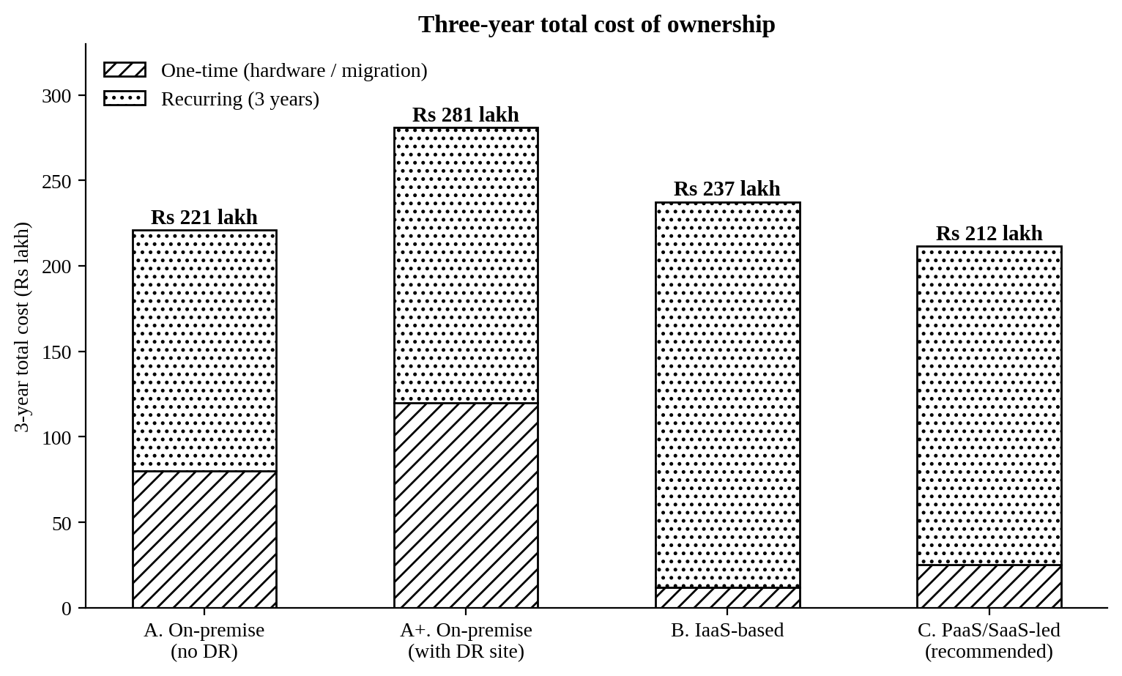
Figure 12: Three-year total cost of ownership of the options
Option C is the lowest cost at ₹211.6 lakh: about 4% below an on-premise refresh that still has no disaster recovery, 25% below an on-premise estate with a DR site, and 11% below the IaaS option. Its advantage does not rest on the price alone. Option C is also the only option that provides automatic elasticity, disaster recovery and the lowest operational effort.

10.3 Risks and mitigation
Table 26: Main risks and mitigation steps
Risk | Impact | Mitigation
Vendor lock-in | High cost and effort to change provider | Use containers, standard databases and open APIs; keep data exportable; test an exit and restore once a year; avoid proprietary services for core logic.
Data privacy and compliance | Breach of student data, penalties under the DPDP Act 2023 | Host in Indian regions, encrypt data, apply role-based access and audit logs, sign data-processing agreements, review provider certifications.
Downtime | Missed admissions, results or exams | Multi-zone deployment, DR in a second region, scheduled scaling before peaks, failover drills, defined SLAs.
Skills gap | Misconfiguration and slow operation | Train staff on cloud fundamentals, appoint a cloud lead, use infrastructure-as-code, start with managed services that need fewer skills.
Cost overrun | Budget exceeded in peak weeks | Budgets and alerts, scaling ceilings, committed-use discounts for the baseline, monthly cost review.
Migration failure | Data loss or service interruption | Phased migration, parallel running, rollback plan, backup before every cut-over.

10.4 Final recommendation
Recommendation: adopt Option C, the public-cloud-led hybrid solution that uses SaaS for email, LMS and library, PaaS for the Exam Portal, IaaS first and PaaS later for the SIS, with DBaaS and DRaaS, deployed in two Indian cloud regions.
Why this follows from the earlier analysis: the consolidation calculation in Task 4 showed that a fixed cluster cannot cover the peaks, which calls for elasticity. The service-model analysis in Task 6 showed that three of the five applications are standard functions better bought than built. The XaaS analysis in Task 7 identified data protection and resilience as the two gaps, which DBaaS and DRaaS close. The cost analysis above shows that Option C is also the cheapest over three years.
Choice of provider. The provider is not chosen for popularity but against criteria: a pair of regions in India (primary and DR) for data residency; managed multi-zone database; a managed container or application platform; education offers for email and learning tools; commitment discounts for the baseline load; and the availability of local skills and support. Amazon Web Services (Mumbai primary, Hyderabad DR) and Microsoft Azure (Central India and South India) both meet these criteria. AWS is used here as the reference design, and the final selection is made after a short proof-of-concept and written quotations from both. The architecture uses containers, standard SQL databases and S3-style storage so that either provider can host it.

10.5 Migration roadmap
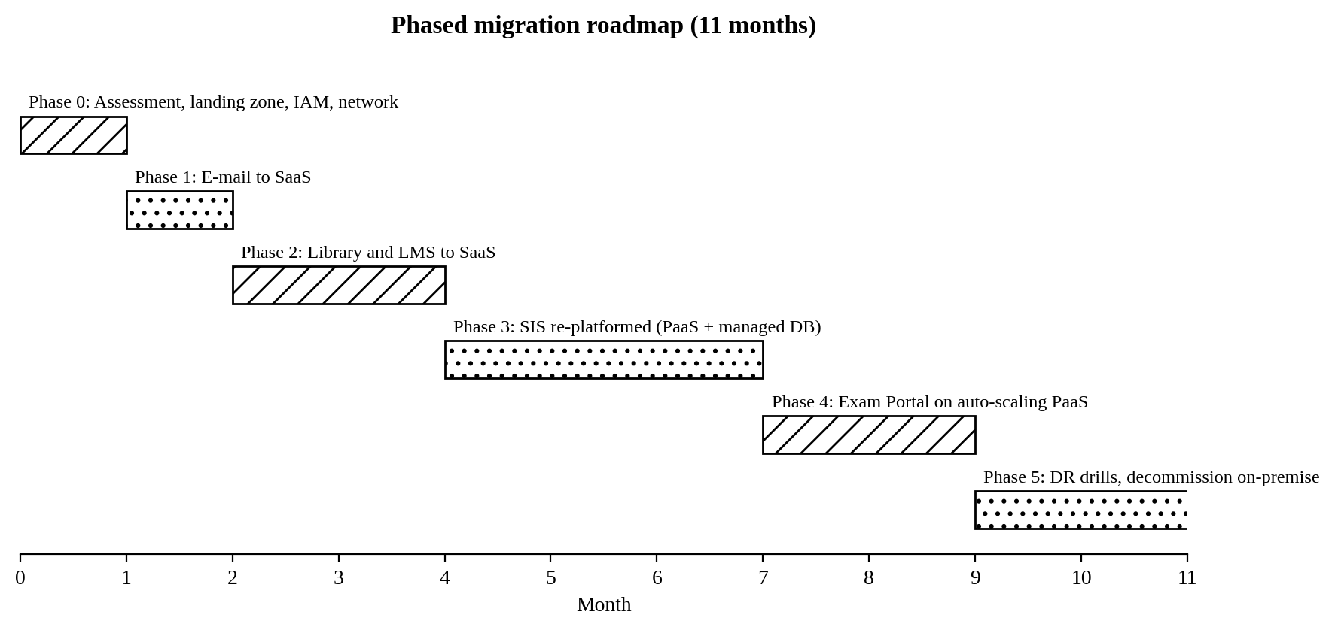
Figure 13: Phased migration roadmap
Table 27: Migration order and reasons
Phase | Application | Reason for its position
0 (month 1) | Foundation: accounts, network, identity, budgets, VPN link | Everything that follows depends on a secure landing zone and single sign-on.
1 (month 2) | Email to SaaS | Moves first because it is a standard service with no code change, delivers an early visible benefit and builds the identity foundation.
2 (months 3–4) | Library and LMS to SaaS | Low-risk services; data import is straightforward; they build the team’s confidence before the critical systems.
3 (months 5–7) | SIS re-platformed with managed database | The largest and riskiest migration, so it starts only when the team and landing zone are mature; the Exam Portal depends on its data.
4 (months 8–9) | Exam Portal on auto-scaling PaaS | Needs SIS data and a load test; it is moved in time for the next exam cycle, with parallel running.
5 (months 10–11) | DR drills and decommissioning of the old servers | Capital is released only after the new services have proven stable and failover has been tested.

TASK 11 – Re-evaluate and Adapt the Design (8 Marks)
Day-4 design challenge: the university will launch a mobile app and open student-record and fee-payment services to 40 affiliated colleges. Expected load is 10 times the current peak, availability must be 99.9% and the operating budget is limited. The original design is retained, modified or redesigned.
Decision in brief: MODIFY. The cloud-first strategy, the SaaS choices and the DBaaS/DRaaS decisions are retained. The application tier is modified into containers behind an API gateway, with a cache, read replicas, three availability zones and a warm standby region. A full redesign is not needed.

11.1 Impact analysis (2 marks)

What has changed and which assumptions are affected
Table 28: Original assumptions compared with the Day-4 requirements
Assumption | Original design | Day-4 requirement | Effect on the design
Load | Peak of about 5,000 concurrent users, 830 requests per second | 10 times the peak: 50,000 users, 8,300 requests per second | The application and database tiers must scale about ten-fold.
Users | 27,000 students and staff on four campuses | Plus students of 40 colleges and mobile users | Many more users, outside the campus network.
Availability | Multi-zone, no formal target | 99.9%, so at most 8.76 hours of downtime a year (about 43.8 minutes a month) | Every serial component and the recovery time are now measured against a number.
Cost | Sized to the current load | Limited operating budget | Elasticity, caching and rightsizing become necessary to control cost.
Interfaces | Internal web access | Public mobile app and partner access | APIs become the main entry point.
Tenancy | One organisation | The university plus 40 colleges | Data and traffic of each college must be isolated.

Why web services and APIs become critical
The mobile app and the colleges never touch the university’s servers directly; they use only the published services. The API layer therefore becomes the front door that must be secure, versioned, rate-limited, monitored and highly available. A weakness there affects 40 colleges at once, and an uncontrolled client could take the whole platform down, so a gateway that authenticates, throttles and routes every call is essential.

Effect of multi-tenant access on security and isolation
- Data isolation: every record carries a tenant identifier, and row-level security in the database ensures that a college can read only its own students.
- Identity: each college has its own OAuth 2.0 client credentials and scopes (for example, read results, create payments); tokens expire and can be revoked per college.
- Fair use: per-tenant rate limits and quotas stop one college from exhausting capacity for the others (the noisy-neighbour problem).
- Auditing and encryption: all access is logged with the tenant identifier, and sensitive fields use encryption keys that can be managed per tenant if required.
- Compliance: student data belongs to the colleges as well as the university, so data-processing agreements and DPDP Act obligations must be defined.

11.2 Evaluation of the original design (2 marks)

Can the service models and virtualization plan handle 10 times the load?
Partly. SaaS services (email, LMS, library) scale by themselves. The weakness is the SIS and Exam Portal tier. The original maximum of 20 instances is more than ten times too small for the new load, and a PaaS plan scales out reactively: a few minutes of delay at the start of a result announcement means failed requests when thousands of students arrive at once. Calculation (Table 29):
Table 29: Capacity calculation for 10 times the load
Quantity | Current peak | Day-4 peak | Working and assumption
Concurrent users | 5,000 | 50,000 | Ten times the current peak.
Requests per second | 833 | 8,333 | Users × 10 requests per minute ÷ 60.
Instances needed | 9 | 84 | Requests per second ÷ 100 per instance (2 vCPU, to be load-tested).
With 30% headroom | 12 | 109 | Instances × 1.3.
Surviving the loss of one of three zones | 14 (two zones) | 126 | 84 instances must remain after a zone fails, so 84 ÷ (2/3) = 126; ceiling set at 130.
Quiet-period minimum | 4 | 20 | About 15% of the peak fleet, spread over three zones.
Queries reaching the database per second | – | 2,333 with cache (8,333 without) | Assuming 90% reads and 80% cache hits: 8,333 × (0.9 × 0.2 + 0.1) = 2,333.

Are auto-scaling and a single region enough for 99.9% availability?
The availability of a system whose components are all required is the product of the component availabilities. Table 30 uses assumed provider SLA figures, which must be checked against the actual SLAs of the chosen provider.
Table 30: Composite availability of the original and revised designs
Component | Original design | Revised design
DNS and CDN | 99.99% | 99.99%
Load balancer | 99.99% | 99.99%
API gateway | not present | 99.95%
Application tier | 99.95% (two zones, PaaS) | 99.99% (three zones, containers)
Database | 99.95% (two zones, standby) | 99.99% (multi-zone, replicas, tested failover)
Composite (product) | 99.88% | 99.91%
Downtime per year | about 10.5 hours (limit 8.76) | about 7.9 hours (limit 8.76)
Result | Does not meet 99.9% | Meets 99.9%, with a thin margin

Two further points matter. First, these figures cover infrastructure only. If capacity is too small for the load, the service fails even when every component is “up”, so capacity planning is part of availability. Second, a regional outage is not covered by multi-zone design. With a pilot-light recovery of four hours, a single regional failure would use 4 ÷ 8.76 = 46% of the annual downtime budget, while a warm standby with a 15-minute recovery uses only 3%. The original single-region design with pilot-light DR is therefore not sufficient.

Cost and alternative service models
Scaling the original design linearly would cost about ₹94.7 lakh a year (Table 32) because it keeps a large fleet running all year, and it would still fail the availability target. Other service models give better value: a mobile backend service for push notifications, FaaS for receipt generation, an API gateway service for authentication and throttling, a managed payment gateway so that the university never handles card data, and SECaaS (managed WAF and bot protection) for the public endpoints.

11.3 Adaptation or redesign (2 marks)
Three choices were considered. Retain the design with larger instance counts is cheap to do but fails the availability target and is slow to scale. Redesign completely into microservices on a self-managed Kubernetes platform would give the best flexibility but would cost the most, needs skills the university does not have and takes about nine months. Modify keeps what already works and changes only the parts that fail under the new requirement. Modify is the selected option.
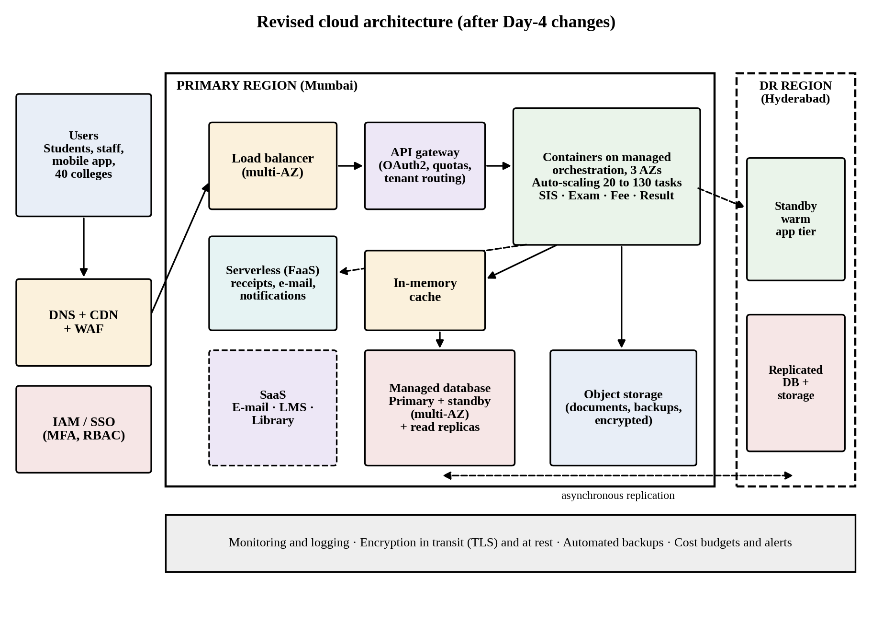
Figure 14: Revised cloud architecture after the Day-4 changes
Table 31: What changes in the revised design
Area | Original design | Revised design
Service-model mix | SaaS for email, LMS, library; PaaS for the application tier; DBaaS; DRaaS (pilot light) | SaaS retained; the application tier moves to containers on a managed orchestration service (container as a service); API gateway as a service; FaaS for receipts and notifications; SECaaS (WAF); DBaaS with read replicas; DRaaS warm standby
Virtualization approach | Virtual machines for the SIS, PaaS runtime for the Exam Portal | SIS decomposed into containers (result, fee, record, exam services) so that each scales on its own; VMs only for remaining legacy components
Scaling | 2 to 20 instances, reactive | 20 to 130 tasks, scheduled scaling before known peaks and target tracking during them
Availability zones and regions | Two zones; pilot-light DR region | Three zones; warm standby in the DR region with automated failover (recovery time about 15 minutes)
Data tier | Multi-zone managed database | Plus read replicas and an in-memory cache to cut database load by 72%
Access | Browser access | API gateway for mobile and colleges, with OAuth 2.0, per-tenant quotas and tenant routing

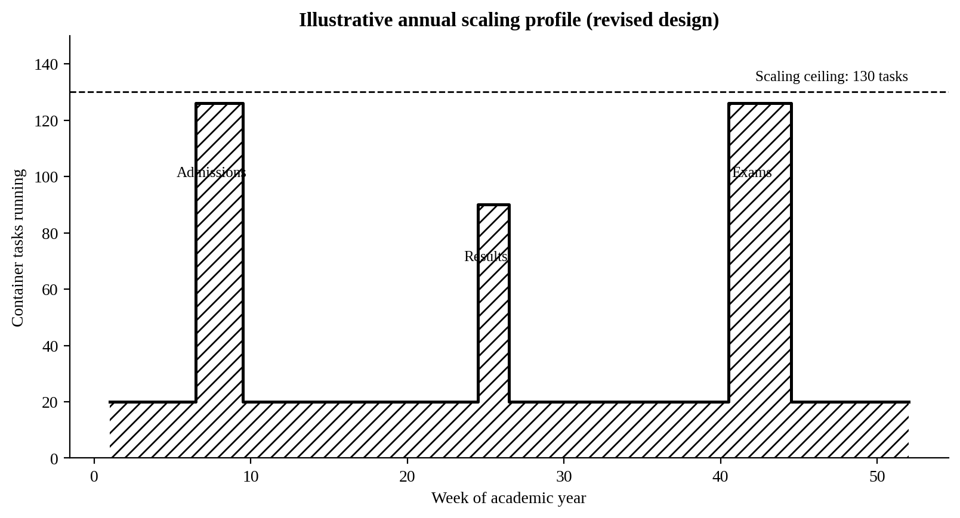
Figure 15: Illustrative annual scaling profile of the revised design

11.4 Evidence-based defence (2 marks)

Capacity and availability
The capacity workings in Table 29 give a ceiling of 130 tasks, which carries the 10-times load even if one zone is lost. The availability workings in Table 30 raise the composite figure from 99.88% to 99.91% and, with the warm standby, a regional failure uses only 3% of the annual downtime budget instead of 46%. Both results rest on assumptions (100 requests per second per task, provider SLAs) that the load test and failover drill in the roadmap will verify.

Cost comparison between the original and revised designs
Table 32: Annual recurring cost (₹ lakh per year)
Cost item | Original design at today’s load | Original design scaled to 10× | Revised design at 10×
Application hosting | 17.0 | 38.3 | 18.6
Database (DBaaS) | 7.2 | 14.4 | 14.4
Cache | – | – | 3.6
API gateway, CDN, WAF, data transfer | – | 4.0 | 6.0
Disaster recovery | 6.0 | 6.0 | 9.0
Monitoring and logging | – | – | 1.5
SaaS subscriptions | 20.0 | 20.0 | 20.0
IT operations staff | 12.0 | 12.0 | 16.0
Total per year | 62.2 | 94.7 | 89.1

Assumptions: one task (2 vCPU, 4 GB) costs ₹7 per hour; peak load lasts about eight weeks a year at full scale; the revised design runs 20 tasks all year with a 30% commitment discount and scales to 126 for the peak weeks, whereas the scaled original keeps about 51 tasks running all year because its plan cannot follow the demand closely. The revised design needs a one-time modernisation effort of about ₹18 lakh.
The revised design costs about 6% less than simply scaling the original, and it is the only one that meets the availability target. Per unit of peak capacity, it costs about one-seventh as much as the original (₹89.1 lakh for 8,333 requests per second compared with ₹62.2 lakh for 833). Because the 40 colleges are the cause of the extra load, the university can recover part of the cost through a service charge. For example, a charge of ₹2 lakh per college would bring in ₹80 lakh a year and reduce the net annual cost to about ₹9 lakh. This is only an illustration and depends on the university’s policy.

Security and multi-tenancy
The gateway authenticates every call, rate-limits each college, and passes a verified tenant identifier to the services. Row-level security in the database and per-tenant audit logs enforce isolation at the data level, and the web application firewall protects the public endpoints. Pooled compute with logically isolated data is chosen because dedicated stacks for 40 colleges would multiply cost and effort; a college with special requirements can be given a dedicated schema or database later.

Trade-offs
Table 33: Trade-offs of the revised design
Trade-off | Effect | How it is managed
Vendor lock-in | Gateway, container platform and managed database are provider-specific | Standard containers, SQL and OpenAPI definitions keep the application portable; exit is tested.
Complexity | More components to operate than the original design | Managed services, infrastructure-as-code and one dashboard; the self-managed Kubernetes option was rejected for this reason.
Migration effort | The SIS must be split into services | Done in stages, one service at a time, beginning with the result and fee services that the mobile app needs.
Cost variability | Peak weeks cost more than quiet weeks | Scaling ceiling, budgets with alerts and a service charge to the colleges.
Shared (pooled) tenancy | A software flaw could expose data between colleges | Row-level security tests, penetration testing and per-tenant audit logs.

Final decision. Modify the original design. The change meets the 10-times load and the 99.9% target within an acceptable cost, reuses the services already planned and avoids the cost and risk of a full redesign.

Rubric Coverage Index and Conclusion
Table 34 lists where each element of the evaluation rubric is addressed in this report.
Table 34: Coverage of the evaluation rubric
Task | Evidence required by the rubric | Where addressed
1 (3) | Definition; characteristics; deployment models; scenario mapping | Sections 1.1 to 1.5; Tables 1 to 3; Figure 1
2 (3) | Timeline; hardware evolution; relevance to university | Sections 2.1 to 2.4; Tables 4 and 5; Figure 2
3 (3) | Web and software evolution; SOA; APIs; scenario relevance | Sections 3.1 to 3.4; Tables 6 and 7; Figure 3
4 (5) | Hypervisor types; VM and container comparison; consolidation; limitations | Sections 4.1 to 4.5; Tables 8 to 12; Figures 4 and 5
5 (4) | SOA and SOAP/REST; three university APIs; request and response examples | Sections 5.1 to 5.4; Tables 13 to 15; Figure 6
6 (5) | Responsibility layers; five-application mapping; comparison; providers | Sections 6.1 to 6.3; Tables 16 to 18
7 (3) | Four or more variants; two justified choices; provider risks | Sections 7.1 to 7.3; Table 19
8 (5) | Labelled diagram; deployment and service models; scaling; security; DR | Sections 8.1 to 8.4; Tables 20 and 21; Figure 7
9 (4) | Running service; PaaS/container; tests; screenshots | Sections 9.1 to 9.6; Tables 22 and 23; Figures 8 to 11
10 (7) | Three-way comparison; three-year costs; risks; phased roadmap | Sections 10.1 to 10.5; Tables 24 to 27; Figures 12 and 13
11 (8) | Impact; evaluation; adaptation; evidence-based defence | Sections 11.1 to 11.4; Tables 28 to 33; Figures 14 and 15

Conclusion
The legacy system sits at the client–server stage of computing evolution, with dedicated and under-used servers that cannot absorb peaks, no disaster recovery and no interfaces for the outside world. The recommended solution is a public-cloud-led hybrid design that consolidates through virtualization, exposes services through REST APIs, and uses SaaS for standard applications, PaaS for the Exam Portal, and DBaaS and DRaaS for data protection and resilience. It is the lowest-cost option over three years. When the Day-4 requirements arrive, the design is modified rather than replaced, by moving to containers behind an API gateway with caching, a three-zone deployment and a warm standby region, which meets the 10-times load and the 99.9% availability target within a limited budget.

References
- Mell, P. and Grance, T. (2011). The NIST Definition of Cloud Computing. NIST Special Publication 800-145.
- Fielding, R. T. (2000). Architectural Styles and the Design of Network-based Software Architectures. Doctoral dissertation, University of California, Irvine.
- W3C (2007). SOAP Version 1.2 Part 1: Messaging Framework. W3C Recommendation.
- Government of India (2023). The Digital Personal Data Protection Act, 2023.

